ARTSA

Combination Vehicle Brake Code of Practice

Part 5
Review of Electronically-Controlled Brake Technologies for Heavy Vehicles

1 Overview of Heavy Vehicle Brake Control Technologies 5
2 Anti Lock Brakes 17
2.1 Common Names 17
2.2 Function 17
2.3 Components 21
2.4 Configurations 23
2.5 International Perspective 27
2.6 Australian Applications 27
2.7 Technical Standa rds 27
2.9 Maintenance 30
2.10 Features and Limitations 33
3 Automatic Traction Control 36
3.1 Common Names 36
3.2 Function 36
3.3 Components 37
3.4 Configurations 38
3.5 International Perspective 38
3.6 Australian Requirements 38
4 Drag Torque Control 39
4.1 Common Name 39
4.2 Function 40
4.3 Components 40
4.4 International Perspective 40
4.5 Australian Requirements 40

5 Electronic Brake (Force) Distribution 41
5.1 Common Names 41
5.2 Function 41
5.3 Components 41
5.4 Configurations 42
5.5 International Perspective 42
5.6 Australian Requirements 43
5.7 Technical Standards 43
5.8 Features and Limitations 43
5.9 Australian Applications 43
6 Trailer Response Management 44
6.1 Common Names 44
6.2 Function 44
6.3 Components 44
6.4 International Perspective 44
6.5 Australian Requirements 45
6.6 Technical Standards 45
6.7 Features and Limitations 45
6.8 Australian Applications 45
7 Electronically (Controlled) Brake System 47
7.1 Common Names 47
7.2 Function 47
7.3 Components 47
7.4 International Perspective 53
7.5 Australian Experience 53
7.6 Technical Standards 54
7.7 Features and Limitations 54
7.8 EBS Programmability 57
8 Trailer Electronically Controlled Brake System 61
8.1 Common Names 61
8.2 Function 61
8.3 Components 61
8.4 Configurations 63
8.5 International Perspective 63
8.6 Australian Requirements 63

9 Roll Stability System 66
9.1 Common Names 66
9.2 Function 66
9.3 Components 69
9.4 Configurations 69
9.5 International Perspective 70
9.6 Australian Applications 70
9.7 Technical Standards 70
9.8 Features and Limitations 70
9.9 Australian Applications 71
10 Electronic Stability Control 71
10.1 Common Names 71
10.2 Function 71
10.3 Components 71
10.4 Configurations 73
10.5 International Perspective 73
10.6 Australian Requirements 73
10.7 Technical Standards 73
10.8 Limitations on Performance 74
10.9 Australian Applications 74
11 Adaptive Cruise Control 74
11.1 Common Names 74
11.2 Function 74
11.3 Components 75
11.4 Configurations 75
11.5 International Perspective 76
11.6 Australian Requirements 76
11.7 Technical Standards 77
11.8 Features and Limitations 77
12 Brake Assist 77
12.1 Common Names 77
12.2 Function 77
12.3 Components 77
12.4 Configurations 77
12.5 International Perspective 77
12.6 Australian Requirements 78
12.7 Technical Standards 78
12.8 Features and Limitations 78
12.9 Australian Applications 78
13 Autonomous Emergency Braking 78
13.1 Common Names 78
13.2 Function 78
13.3 Components 79
13.4 Configurations 79
13.5 International Perspective 80
13.6 Australian Requirements 80
13.7 Technical Standards 80
13.8 Features and Limitations 80
13.9 Australian Applications 80
14 Lane Departure Warning 81
14.1 Common Names 81
14.2 Function 81
14.3 Components 81
14.4 International Perspective 81
14.5 Australian Requirements 81
14.6 Technical Standards 81
14.7 Features and Limitations 81
14.8 Australian Applications 82
15 The Controlled Area Network (CAN) Communication Bus 82
16 Glossary 87
17 Acknowledgements 89

Other Code Parts
Part 1 Guide to the Selection of Brake Technologies for Combination Vehicles
Part 2 Workshop Guide to Combination Vehicle Brake Set-Up
Part 3 Assessment of Brake Balance on Heavy Vehicles
Part 4 Australian Combination Vehicle Braking Performance

SCOPE
A review of the electronically controlled service-brake technologies that are
being used on Australian heavy trucks and trailers (with GVM and GTM
greater than 12t), is presented.

1 Overview of Heavy Vehicle Brake Control Technologies

This Part gives a detailed description of the electronic brake control technologies that are being
applied to heavy-vehicle service brake systems with pneumatic service brake systems. The foundation brakes may be drum or disc brakes. The emergency brakes and park brakes are applied by spring pressure.

Revolutionary changes are occurring with heavy-vehicle pneumatic brake* systems. Intelligent electronic control is being added to control the base pneumatic system. The intelligence is being used to provide the following features:

Improved brake distribution balance on the vehicle (i.e. the sharing of the braking effort between the axles on one vehicle part).
2 Improved compatibility brake balance between vehicles in a combination (i.e. the sharing of the braking effort between vehicle parts in a combination).

Improved brake wear (by biasing the brake effort away from worn brakes),
- Faster brake response by use of electronic communication between vehicles in combination.

Roll-over protection by slowing the vehicle when a pending roll-over is sensed (by applying some or all the brakes).

Vehicle stability improvement (electronic-stability and roll-stability systems) in response to developing under-steer and over-steer conditions (by applying individual brakes to alter trajectory or to slow the vehicle).

Maintenance of a safe braking distance in a traffic flow (by adjusting cruise control speed and applying all the brakes if necessary).

Collision avoidance by applying all the brakes to slow the vehicle when a potential collision is likely or unavoidable.

* Unless otherwise stated, references to ‘brakes’ means the service brakes that are normally
operated by the foot pedal control valve.

These developments build upon the established wheel slip-control technologies:

Antilock Brake System (ABS), which cyclically reduces, holds then re-applies individual brake air pressure when wheel lock-up is pending.

Automatic Traction Control (ATC, ASR), which applies individual drive-wheel brakes to limit drive wheel slip under tractive effort.

Additionally, development of mechanical brake technologies are extending the performance of brakes:

Disc brakes produce greater torque than drum brakes when compared at the same physical volume size or weight. Disc brakes have superior high-temperature (fade) performance and are now acceptably reliable.

Load Sensing Brakes (LSB) alters the ratio between the axle brake pressure and brake control pressure depending upon an indication of the load on the axle. The LSB is implemented by a pneumatic valve that is settable. On trucks the rear brake group is controlled. Occasionally the front axle is also controlled in response to the rear-axle load. On a semi-trailer the rear-brake group relationship is altered. On a dog trailer both front and rear group ratios are altered. When properly adjusted and with a reliable weight level signal, load sensing brakes improve the brake balance on a lightly laden vehicle and reduce the propensity to lock-up wheels.
If this review Load Sensing Brakes refers to a mechanical system for changing the brake distribution on a vehicle in response to a load signal. Brake distribution can also changed electronically on some systems. This function is referred to as Electronic Brake Distribution (EBD).

13 Auxiliary brakes such as engine brakes and retarders are steadily becoming more powerful.

The hierarchy of current brake technologies is shown in Figure 1. The diagram shows the range of technologies that are now used and estimates the extent of use.

The majority of Australian motive trucks have drum brakes without load sensing brakes. Antilock brakes are now common and are on the majority of new trucks.

Electronic Brake Control System (EBS) which incorporates Electronic Brake Distribution is now standard on most European motive trucks.

Disc brakes are common on European trucks and are becoming common on trailers. They are available on some North American, Australian and Japanese trucks although the application rate is relatively small.

Japanese motive trucks commonly have ABS. EBS is starting to be available on some Japanese trucks. Disc brakes are available on Japanese trucks.

Some Australian trucks now have a form of advanced Antilock Brakes which incorporates Electronic Brake Distribution.

Most new trailers are manufactured in Australia. The majority have drum brakes, no ABS and are not load-sensed. Trailers used for dangerous goods haulage usually have ABS and may have trailer EBS. A significant minority of new general-freight trailers now have disc brakes and a small but growing proportion have trailer

Load Sensing Brakes alter the braking power applied to some axles in response to the loading level on the truck. Commonly the air-bag pressure of the rear-axle group air suspension is used as a measure of load. Load-Sensing Brakes have become more common over the past ten years because of the widespread use of air-suspensions. The air-bag pressure level provides a reliable weight indication. Use of lever mechanisms to indicate weight based on rear spring-sag has a poor reputation because this system can get out of adjustment.

Disc Brakes are making a come-back on Australian heavy vehicles. Disc Brakes were tried in the 1980’s and 90’s. Reliability and installation space problems limited their acceptance. Disc brakes offer superior retardation force per kilogram compared to drum brakes (i.e. are lighter). They also have superior high-temperature (fade) performance and air-cooling capability.

If the brake balance on a combination vehicle is poor, it is possible that disc-braked axles will absorb proportionately more braking energy and wear quickly. In particular, the mixing of disc and drum brakes on a combination vehicle without proper brake balance could result in excessive disc brake temperatures.

Automatic Brake Adjustment tightens the brake adjustment on individual service brakes with each brake application. The adjuster incorporates a special mechanism that increases the adjustment minutely when the brake is released. It uses the energy of the brake application to do this. Automatic Brake Adjustment is standard on disk brakes. It is used commonly on drum brakes in association with Antilock Brakes (ABS).

Auxiliary Brakes are commonly installed on motive trucks. There are five types:
- Exhaust brakes. Which increase engine retardation when the throttle is released by mechanically blocking off the exhaust and creating high engine back-pressure. Exhaust brakes produce only modest retardation forces.
- Engine brakes. These operate by altering the valve timing of the engine and provide substantial engine retardation. The engine acts as a 2-cycle air compressor and the energy is released via the exhaust. Engine brakes produce relatively high retardation force. Retardation power is in line with engine output power. Peak engine brake retardation force is typically about a quarter of peak service brake retardation force.
- Transmission retarders. These generate retardation force by causing a rotor to spin in oil and thereby creating hydraulic drag. Transmission retarders can be as powerful as engine brakes.
- Tail-shaft retarders. Usually these are electromagnetic induction devices that produce heat in a rotor by magnetic field action. Tail-shaft retarders produce high retardation force levels comparable with or greater than engine brake levels.
- Regenerative brakes. These generate electricity in a generator when the vehicle is braked or coasting-down. The electricity is used to charge batteries.

All these Auxiliary Brakes provide retardation force via the drive wheels. There is no limit in the in any road rules to the level of auxiliary braking that can be applied. Nor are there any Australian technical control or performance standards for auxiliary brakes. Occasionally vehicles have two types of auxiliary brake installed.

Powerful Auxiliary Brakes can affect the brake balance performance on motive trucks. Auxiliary brakes act through the rear-axle group only and hence they alter the brake distribution balance when active during a service brake application. Many systems can apply automatically when the throttle is relaxed. This might lock the drive wheels under slippery conditions.

Auxiliary brakes are not used on trailers, however there is some interest in developing electromagnetic retarders for trailers.

Retractable (Lift) -Axles are commonly used. These are controlled by electronic systems that cause one or two axles in a group to be lifted when the weight on the group falls below a present level. Lifting the axle reduces the brake capability of the group. Such systems are not adaptive brake control technologies because they operate at particular set-points. They are important and useful although they are not discussed further here. Australian Design Rule 43/04 specifies the prescribed transition mass of a lift axle group. This is the weight on the axle group at which the retractable axle must be automatically raised or lowered. The weight is usually sensed using the air-suspension bag pressures on the static axle.

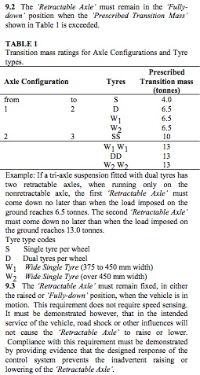

ADR 43/04 prescribed transition masses for retractable axles.

Commonly used
1 Drum Brakes
Mainly S-Cam and rarely Wedge Brakes. Used on ~ 80% of new vehicles.
with or without automatic adjustment
2 Disc Brakes
Always has automatic brake adjustment. Used on ~20% of new vehicles.

6 Load Sensing Brakes
Reduces the brake power distribution between axles on a vehicle by mechanical means when the load is low
7 Anti-Lock Brakes (ABS)
Prevents wheel lock-up on controlled wheels by interrupting braking to selected wheels
8 Traction Control (ATC)
Prevents wheel slip on driven wheels by applying selected drive wheel brakes
9 Electronic Brake Distribution (EBD)
Distributes braking effort between axles on one vehicle.
12 Electronic Brake Control (EBS)
Electronic communication between sensors, valves and ECM
Electronic brake distribution, wear balancing, trailer control.
Trailer EBS (TEBS)
14 Trailer Roll Stability (TVSS)
Autonomous braking to reduce speed when roll-over is pending.
16 Electronic Stability Control (ESC)
Autonomous braking of selected wheels to reduce speed and improve trajectory
17 Adaptive Cruise Control (ACC)
Maintains a safe following distance
- Brake Assist (BAS)
Manages severe braking events
18 Autonomous Emergency Braking (AEB)
Applies brakes to minimize potential collision
consequences
First applications on ABS in Australia
Extensive Australian experience on a minority of new vehicles
Emerging new technologies are now available on a range of trucks
Emerging new technology is being demonstrated in Europe
3 Automatic Brake Adjustment
Automatically tightens the brake adjustment with each application
19 Lane Departure Warning (LDW)
Warns the driver when an unintended lane deviation occurs
5 Drag Torque Control (DTC)
Adjusts engine torque to minimized drive wheel slip due to auxiliary brake operation.
10 Trailer Response Signalling (TRS)
Provides a CAN bus signal of the desired control level to the trailer(s).
15 (Hill) Start Assistance (HSA)
Applies the brakes at startup to prevent roll back.
Integral with some EBS systems
11 Coupling Force Control (CFC)
Manages the trailer brake air control signal level according to calculations
Usually a fetaure of trailer EBS
4 Auxiliary Brakes
Exhaust Brakes, Engine Brakes, Transmission Brakes, Tailshaft Betarders, Regenerative Brakes

(a)

Drum Brakes

Disc Brakes
Foundation
Brakes
Antilock Brakes & ATC
Wheel lock protections

Electronic Brake Systems

Load Sensing Brakes

Vehicle Stability Stability
Adaptive
Brake Balance Controls

Traction Control
Autonomous Braking Systems

Adjustable Trailer Valves
Static

Adjustments

Collision Avoidance

Electronic Brake Distribution

Autonomous Cruise C

(b)

Figure 1 (a) The current sophistication hierarchy of brake technologies (2010).

(b) Classification of adaptive, wheel-lock protections and autonomous brake
control technologies

Note that the Antilock Brake function is the entry level for electronically-controlled brakes and that the technologies 7 – 19 in Figure 1 include an antilock brake function.

European

Japanese

European

Nth American

Australian

Trailers
Predominant
Minority
Available, uncommon

Trial / First applications
Not Available
Trucks
1 Drum Brakes
2 Disc Brakes

4 Auxiliary Brakes

6 Load Sensing Brakes
7 Anti-Lock Brakes (ABS)
8 Traction Control (ATC)

9 Electronic Brake-Force Distribution (EBD)

12 Electronic Brake Control (EBS)
Trailer EBS (TEBS)
13 Brake Assist (BAS)
14 Vehicle Roll Stability (VSS)

16 Electronic Stability Control (ESC, ESP)
17 Adaptive Cruise Control (ACC)

18 Autonomous Emergency Braking (AEB)
19 Lane Departure warning (LDW)
5 Drag Torque Control (DTC)

11 Coupling Force Control (CFC)

15 Hill Start Assist (HSS)
10 Trailer Response Signalling (TRS)

3 Automatic Brake Adjustment

Figure 2 Australian application of brake technologies (2010)

Europe and North America are heading towards mandated Electronic Stability Control (ESC) for new heavy vehicles. The European vehicles will achieve this on an EBS base (‘platform’). The North Americans will achieve this on an ABS base (‘platform’). There is now substantial cross-ownership of brake technology suppliers and truck manufacturers between Europe and North America. It seems likely that over time the technologies from Europe and North America will merge. Europe has mandated ESC on trucks and trailers with staggered introduction dates from 2010. The UN ECE working group W29 is attempting to develop an international Global Technology Rule for ESC on heavy vehicles.

The Australian heavy-vehicle marketplace has a mix of North American, European and Japanese technologies. Whilst there is a significant Australian truck and trailer manufacturing industry, Australian manufactured trucks and trailers tend to have North-American oriented brake systems.

Australia considered mandating Antilock Brakes on heavy vehicles in the 1990s but the cost-benefits were judged to be negative. Antilock Brakes are mandated on new B-double prime-movers and on dangerous goods trailers used in a B-Double. Despite these limited requirements, ABS is now supplied on about 70% of new Australian-delivery motive heavy trucks as a result of the international trends and because of B-double ADR requirements. In contrast only about 20% of new Australian trailers have ABS.

There is a common view in Australia that ABS is mainly suitable for wet and icy conditions commonly found in Europe and North America but is unnecessary on Australian roads. The opposition is based on perceived unreliability and on a tendency to increase stopping distances, particularly on unladen trucks and in particular on gravel roads. It is likely that unreliability of ABS is the mainly due to poor maintenance practices on heavy trailers and poor wiring installation standards. The argument that ABS will necessarily increase stopping distances is fallacious for sealed roads but can be true for unsealed roads with loose surfaces. There is however, a compensating improvement in directional control when ABS is used in all situations.

This perception is changing as an extensive experience of the system develops and as additional functionality become available. The latest generation of ABS has added intelligence and better controls the build up of brake pressure to prevent wheels getting into the lock-up zone.

The use of advanced electronic braking and stability technologies on gravel roads is unproven because operational experience is sill being gained. Stability systems factor in information about yaw velocity, lateral acceleration and wheel speeds. Roads that have frequent camber changes, frequent changes of friction level or potholes may be challenging to deal with. Fine tuning of stability systems will probably occur as a wealth of operational experience is gained.

The development of advanced brake technology for heavy vehicles is being driven by European suppliers and has been embraced by European regulators and European truck builders. UN ECE Regulation 13 that has the status of an international brake rule, mandated antilock brakes on both motive trucks and trailers from 1991. A large number of countries (including Japan) now mandate ABS on heavy vehicles because their rules are based on ECE Regulation 13.

ECE Regulation 13 has recently been amended to require Vehicle Stability System (VSS) (features 5 & 6 above). The European Union will mandate VSS progressively on new heavy vehicles from 2011. In Europe VSS is built upon an EBS (Electronically Controlled Braking System) platform, although EBS is not being mandated.

The North American development of ABS began in the 1970s, however these systems were unreliable. Subsequently ABS was mandated on North American (USA and Canadian) heavy vehicles from 1997. The technology is now mature and reliability problems are minimal.

The USA highway administration will mandate VSS on new light vehicles (up to 4.5t) from 2014 and future requirements on heavy vehicles can be anticipated. Heavy vehicle VSS has been developed as an extension of ABS for US market. VSS is now available on most North American motive truck models. Autonomous Cruise Control (ACC) and collision mitigation systems (AEB and BAS) are being developed for North American trucks. ACC is available on some European and Australia truck models.

The application of electronic brake control technologies to heavy vehicles in North America is following a different path than in Europe. European stability and collision mitigation systems are being added to electronically controlled brake systems (EBS) with load-sensing brakes. In contrast North American stability and collision mitigation systems are based on antilock (ABS) systems without load-sensing brakes.

A significant difference between the North American and European approaches to heavy vehicle braking is that the European rules have been concerned with brake balance (encompassing distribution balance on each vehicle and compatibility balance between vehicles in a combination) in both laden and unladen conditions. Consequently most European vehicles meet unladen brake compatibility limits using either Load Sensing Brakes (LSB) or the distribution features in Electronic Brake Systems (EBS). In contrast North American brake systems do not have LSB’s or Electronic Brake Distribution (EBD).

Electronic Brake Distribution (EBD) is an alternative to mechanical load-sensing brake controls for motive trucks. This technology can be added onto antilock brakes. Indeed it is an enhanced antilock brake system because it tries to manage wheel slip before lock-up occurs. EBD alters the brake balance between axle groups by reducing the brake level of the rear group to achieve improved use of the road friction. It is now possible to purchase EBD on some Australian made truck models.

Electronically Controlled Brake Systems (EBS) have recently become available on some Japanese heavy vehicles in Australia. Japanese vehicle manufacturers are following the European path and are applying European-manufactured technology but with different settings. A significant difference is that Japanese EBS systems does not assume that trailers comply with the ECE Regulation 13 unladen compatibility limits (which effectively requires load-sensing brakes) whereas the European systems do. It is usual practice for trailers in continental Europe to have either load sensing brakes or Trailer EBS, set in each case to comply with the ECER13 compatibility limits.

Whilst European EBS systems monitor the air-bag suspension pressure and hence get an estimate of the laden weight, the electronic distribution function (1) is primarily based on the measured wheel slip differences between the front and rear axle groups. For spring suspensions sensors that optically measure spring deflection as a weight indicator now exist.

The advanced brake technologies now becoming available or established on European motive heavy vehicles that are marketed in Australia, are usually offered with disc brakes.

The electronic brake technologies ABS and trailer EBS are proven on single and multiple trailer combinations. Power supply challenges exit on long combination trucks because of the heavy current draw that occurs when all the modulators are active. Most trailers have 12V electrical systems which struggle to provide the current level.

CAN communication issues for multiple trailers are now solved. European equipment developers did not adequately consider multiple trailer applications in earlier designs. Use of multi-combination vehicles by Scandinavian countries together with feedback from Australia has resulted in revised EBS systems with independent CAN communication with multiple trailers. CAN identifiers for multiple trailers have been recently introduced into international standards.

In the past decade trailer EBS with roll stability protection has become available for Australian trailers. The roll stability feature in particular, is attracting interest because of the incidence of trailer-induced roll-overs in Australia. Perceptions amongst trailer owners are changing because of the advanced features offered by current generation electronic brake systems and the improvements to ABS performance that have occurred.

It is desirable to have load-sensing brakes with ABS so that the potential for wheel lock-up when the vehicle is unladen is greatly reduced. Hence ABS becomes a protection of last-resort rather that a system that routinely operates during normal braking. Because ABS modulation temporarily reduces (but does not completely release) the braking level, there is some ‘wasting’ of the available road friction during full-release modulation. On the other hand the benefit is improved directional control during moderate / heavy and emergency braking.

By keeping the wheels turning the directional stability of the vehicle is improved, which is a significant benefit for road safety. However, if this is achieved at the expense of poorer stopping distance then some safety benefits will be lost. Modern ABS systems now achieve comparable or improved stopping performance on good quality sealed roads to the non-ABS equipped vehicle. Therefore ABS can deliver a safety benefit by greatly improving directional control during braking.

When ABS was mandated on European heavy vehicles in 1991, Load Sensing Brakes were made optional (in ECE Regulation 13), although most vehicles continued to have then. In part this reflected the difficulty in achieving good brake balance when load-sensing is used on some but not all vehicles in a combination. The unladen brake compatibility limit in UN ECE Regulation 13 (Diagrams 2, 3 and 4) provide a reference point for the set-up of both mechanical and electronic load-sensing schemes.

Whilst ABS is not mandated in Australia (other than for B-Double prime-movers), there are Australian technical standards for Antilock Brakes in the Australian Design Rules 35 and 38. These do not require and onerous antilock performance tests. An ABS that increases stopping distance is acceptable so long as the vehicle achieves national stopping distance standards.

An associated significant development is that electronic brake controllers now record details of abnormal braking or pending roll-over events. This information is available to assist diagnostic, maintenance and identification of dangerous locations. For example, substandard brake performance on individual wheels is indicated by abnormal wheel speed during braking. This diagnosis can be reported. Recently third-party data recording systems have become available that record the GPS location of severe braking events and / or pending roll-over events.

The Australian design rules do not mandate load-sensing brakes but recent amendments require that when they are used, the vehicle meet ‘compatibility limits’ that are based on the UN ECE Regulation 13 prime-mover limits.

It is inevitable that applications of advanced brake technologies will become commonplace in Australia because of international trends. It seems likely that North American motor truck manufacturers will progressively introduce Electronic Stability Control (ESC). Japanese manufacturers are already following the European lead.

It is likely that Australian brake regulations will be amended in the future to adopt technical standards for advanced brake technologies that are being developed by the UN ECE.

The principal challenge with heavy vehicle braking is to cope with the significant load changes that occur. The second challenge, at least in Australia, is to deal with the mix of brake technologies and brake designs on combination vehicles.

Achieving acceptable brake balance on Australian heavy combination vehicles is a challenge because of the mix of different mechanical brake technologies in the Australian marketplace. The availability of advanced electronic brake technologies adds another challenging factor because new incompatibilities can occur. One of the aims of this Code of Practice is to give guidance about how to maximize the brake performance with mixed brake technologies.

It is clear that advanced brake technologies have the potential to reduce heavy combination vehicle stopping distances by ~ 25% or more with improved directional stability. Significant road safety improvements will be possible on busy roads where heavy vehicles currently have restricted stopping space. The challenge here is to identify the technical challenges that could arise with mixtures of brake technologies and to provide effective guidance on how to achieve reasonable brake balance involving mixed brake technologies..

Table 1 gives a guide to the legal requirements for advanced brake technologies in Australia and its main supplier countries.

The following pages provide a guide to electronic braking technologies on heavy vehicles.

 | Europe | North America | Japan | Australia
Load Sensing Brakes | Pre 1991 | No | No, but common on mid-sized trucks | No.  Planned but not confirmed to require LSB on trailers from 2011 as an alternative to ABS
Antilock Brakes | 1991+ | 1997+ | 2000+ | B-double prime movers since 1991.  Planned but not confirmed to require ABS on trucks from 2011. Optional on trailers with LSB, otherwise mandated.
Electronic Brake Distribution (EBD) | No, but incorporated in to EBS. | No | No | No
Electronic Brake Systems (EBS) | No, but now common | Not Available | No. | No
Electronic Stability Control (ESC) | Progressively from November 2011 | 2011 for mid-sized trucks (4.5t).  Plans for heavy trucks are yet to finalized. | Not announced | Planned but not confirmed from 2015 for trucks and trailers
Autonomous Emergency Braking (AEB) | Progressively from 2013 | No | No | No

Table 1 Mandated Technologies – Heavy Vehicles

2 Anti Lock Brakes

1 Common Names
The acronym 'ABS' is now universally used for Antilock Braking System.

Anti Lock Brakes

Anti Lock Braking System

Anti Skid

2.2 Function
An electronic control system that acts to prevent wheel lock-up on the controlled wheels during braking by altering (‘modulating’) the brake air pressure in response to wheel speed signals. In the first stage modulation involves first stopping brake pressure build-up and in the second stage releasing brake pressure before allowing brake pressure to build up again.

Standard ABS does not apply any of the brakes.

ABS comprises wheel speed sensors, electronic control unit, and electro-pneumatic pressure control valves. The Antilock system monitors the wheel slip on the sensed wheels and manages the brake air pressure applied to the controlled wheels to prevent the wheel slip reaching the lock-up level.

Antilock Brake Systems operate by measuring the wheel speed on the sensed wheels and estimating the ‘wheel slip’.

Wheel slip = 1- actual wheel speed / free running wheel speed

Figure 3(a) shows a typical ABS for a motor truck and Figure 3(b) for a semi-trailer. Usually one wheel on each side of an axle group is sensed and all wheels in the axle group are controlled.

Figure 4 illustrates the relationship between wheel slip and the available braking (longitudinal) and stabilizing / steering forces (lateral).

Peak friction occurs at a wheel slip in the range 10% - 20%, depending upon numerous factors such as the type of surface, wet or dry, rubber compound, tread condition, vehicle speed, etc. One peak friction is reached, wheel lock-up occurs soon after.

Anti-lock brakes act to prevent the wheel slip of the sensed wheel from reaching ~20%. It does this by firstly blocking the brake air pressure build-up to the wheel. At a second stage it may reduce the brake air pressure before allowing the build up to proceed again. The process of reducing brake air pressure followed by allowing build up is commonly called modulation.

Other wheels in the same axle group that are not sensed may be controlled in the same way.

The ABS controller does not have an absolute measure of the free-running wheel speed. Rather, it monitors the variation of wheel speed between the sensed axles. Effectively it ranks the speeds of the sensed wheels and estimates the likely wheel slips from these measurements. It also predicts the sensed-wheel decelerations based on recent history.

Vehicles in combination may consist of parts with and parts without Antilock brakes. There is no control communication between ABS systems on different vehicle parts (other than transmission of fault signals).

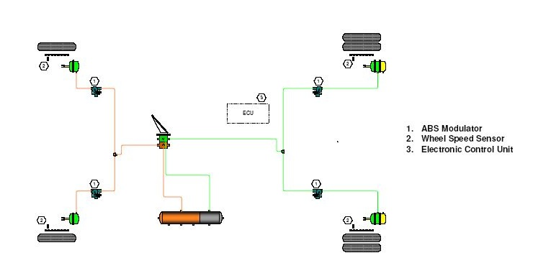

Figure 3 (a) Typical ABS system for a truck 4S/4M system on a two-axle truck (Courtesy Bendix Corporation)
.

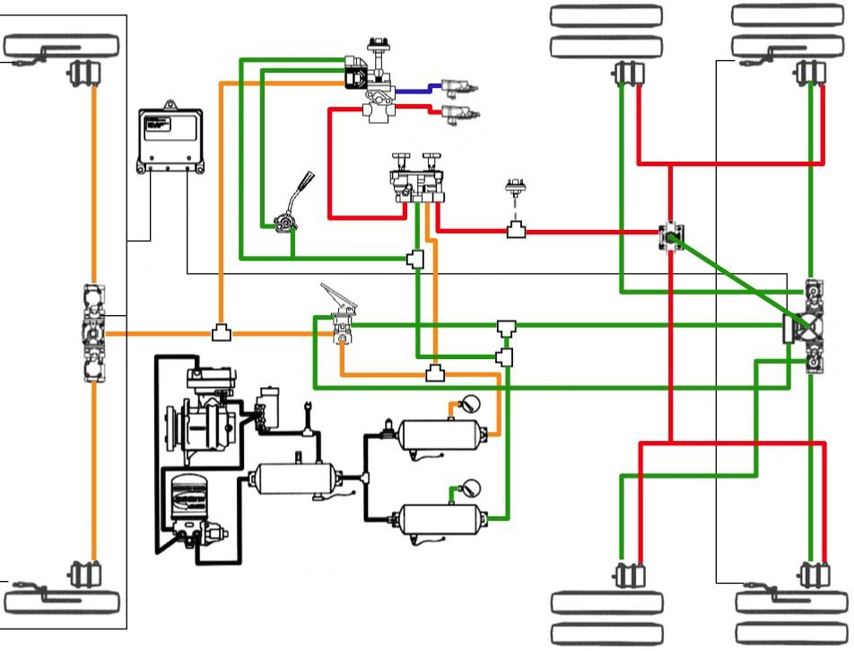

Figure 3(b) ABS system for a three-axis truck 4S/4M system installed with sensors on the rear-rear axle (‘select low’). (Courtesy Bendix Corporation)

Braking / Stability Force per kilogram transmitted from tyre to road
(called the braking coefficient or friction utilization)

Both the longitudinal and the transverse forces that the tyre can transmit to the road are reduced by: Reduced road friction (wet, greasy, loose, frozen,..)
Reduced tyre friction
(bald, hard compound, patterns, bad pressure..)
Reduced contact pressure
(poor inflation, skipping, unloading,..)

No ABS action. EBD domain

ABS release zone
ABS hold zone
Longitudinal – traction & braking
~0.8g
Transverse- stability, steering
Slide values are ~60-70% of the peak valve
Rough pavement ~0.8g

Smooth pavement / wet surface 0.4 – 0.5 g

Piling effect.
Loose material piles in front of the tyres
~0.44

Gravel surface
0.2 – 0.4g

Ice ~ 0.1g

0 ~10 % ~15 % 100% wheel slip
Free
running

Wheel slip = 0 % when wheel is free wheeling.
100 % when wheel is fully locked.

Maximum braking forces occur somewhere in the wheel slip range 10% - 30%
Wheel slip always exists during braking. It is necessary to generate the retardation forces. The aim should be during heavy braking to have all the wheels slips less than ~ 10%.

The slip curve also applies to tractive effort.

Figure 4 Illustration of the relationship between tyre slip and braking coefficient.

ABS systems for trucks can have an off-road mode which is selectable by the driver. In this mode the antilock controller is more tolerant of developing wheel lock-up and will let the wheels fully lock before releasing. This is done to achieve shorter stopping distances on loose surfaces.

Percentage tyre slip measures the extent to which the tyre is turning relative to the free running rotational speed. For example an 11R22.5 tyre which has free rolling turns of 315 turns / km may turn at 290 turns / km during braking. The wheel slip is about 8%.

Tyre-pavement friction level depends upon the road surface roughness, lubrication / water, ambient temperature and tyre construction. Tyres with hard rubber compounds, such as off road tyres have lower peak friction utilization than do softer compound tyres.

The state-of-the-art peak utilization value for a truck tyre on a rough bitumen road is about 1.0. This sets the ultimate deceleration level for a perfectly balanced and powerful brake system to 1g (9.98 m/s²). As a guide high load carrying tyres such as 295/80R 2205 & 11R22.5 tyres have a peak friction level of about 0.9g on a rough sealed road. Tyre compounds and road roughness will affect this value marginally.

Notice in Figure 4 that the slide values for stopping / traction force are proportionately higher than the slide values for cornering / steering force. A locked-up wheel provides low road handling force and minimal steering force. Consequently the main benefit from ABS operation is to maintain directional control of the vehicle during heavy braking. In some circumstances the stopping distance may be increased however, the directional control of the vehicle is substantially greater than if the wheels are locked up.

2.3 Components

Electronic Control: The control unit that monitors wheel speed sensors and activates up
Module (ECM) modulation valves to prevent wheel slip on the sensed wheels.
The ECM predicts the free-running wheel speed by averaging all the wheel speed values. It then estimates the wheel slip of each of the sensed wheels. Control action is implemented in response to estimated wheel slip values.

Wheel sensor: The wheel speed signal is a sinusoidal pulse waveform generated in a coil of wire wound onto a magnetic core that responds to ferro-metal teeth on a rotating pole ring that is attached to the wheel (Figure 6).

The strength of the signal depends upon the air gap between the sensor and pole ring as well as wheel speed, pole ring diameter, and sensor efficiency. A gap in the range 0.3 – 0.6mm is desirable, the smaller the better.

ABS systems monitor the wiring to the wheel speed sensors. If an open-circuit exists a fault will be registered. Excessive air gap setting cannot be sensed until the vehicle moves and the relative strength of the various signals can be compared.

Modulation valve: The modulation valve is an electro-pneumatic valve that controls
(Modulators) the brake air-pressure that reaches the brake actuators. The valve has three states, which are:

Off or no-action. The air pressure of the brakes is unaffected.
Hold pressure: The valve blocks the build up of air pressure and holds the pressure in the brake actuator.
Vent: The valve reduces the brake actuator pressure through an exhaust port. The incoming pressure is blocked.

The process of first blocking and then reducing brake pressure is termed modulation. Once the pressure is reduced, the wheel speed picks up and the ABS again checks whether modulation is necessary. On an air-braked vehicle there will be 3-5 modulation cycles per second.

The control functions are achieved by activating two electrical solenoids in each valve.

For multiple axle groups, the modulation valve is installed between the relay valve and the actuators. One modulator usually has the capacity to control two axles.

Sophisticated Anti Lock brake systems will block pressure build up as necessary and minimize the need for modulation cycles.

Normal pressure release from the brake actuators occurs through the modulator without any control action. That is, the modulator has a quick release function.

When the ignition power is turned on the ABS will check for a modulation valve connection and fast response. It registers a fault condition if the electrical response is unacceptable.

Warning lights: A red or amber ABS warning light is provided in the vehicle cabin. Typically flashes prior to the speed reaching about 15 km/h above which all the wheel speed signals should be confirmed and the light goes out.

The lamp will show continuously if:
- a wheel speed signal is absent or too small,
- a modulation valve has a slow electrical response or an abnormal current,
- the power supply has failed,
- an open or short circuit exists in any external wiring, or
- internal ECU faults are sensed.

For combination vehicles that have a trailer ABS connector, a second ‘trailer’ ABS warning light is provided. The responds to pin 5 on the trailer connector being earthed. The trailer ABS ECM should ground pin 5 when a fault condition exists.

Some models have an auto-blink diagnosis via the warning light.

Wiring looms: Wiring looms are usually provided with the Anti Lock Brake kit of parts.

To meet dangerous goods vehicle standards (specified in AS2809:2008) wiring must be double insulated and of a suitable plastic insulation that has self-extinguishing properties. The electrical components and all connections must be liquid proof with a PI66 (or better) rating.

The wheel sensor wiring can be light gauge. The wiring to the ECM is moderate gauge suitable for 10A draw. The wiring for the modulation valves is heavy gauge and suitable for 25A modulation current levels.

Individual fuse protection for each modulation valve and for the ECM is usually provided.

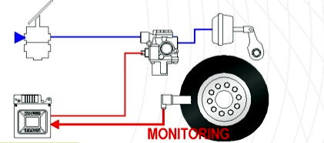
Modulation
valve
ECM

Figure 5 One channel of an ABS system. The blue paths are pneumatic. The red paths are
electrical. (Courtesy Wabco)

ABS trailer connections on the towing vehicle: Are optional. Many prime-movers with ABS do not have a trailer ABS connector. When provided the ISO 7638-2(12V) or ISO7638-1 (24V) five-pin connector is required.

2.4 Configurations

Motive Trucks S = Sensors M=Modulators

2S/2M A single-axle system. Two sensed wheel ends on one axle and two modulation (2S/2C) valves controlling that axle. This system is not allowable on motive trucks in

Australia because it does not meet the ADR requirement that all wheels on the vehicle be controlled.

4S/3M Sensors on four wheels on two axles (a front and a rear axle). The steer axle
(4S/3C) wheels are modulated together (one modulator) and the rear axle has two modulators. The rear axle(s) have independent side modulation. This scheme is rarely if ever used in Australia. The rationale for it is that ABS modulation on one side of a steer axle might cause a steering effect under heavy braking. Hence the steer axle has a single modulation valve that controls both sides.

This configuration is often used on air-over-hydraulic (AOH) brake systems that are common on light-medium commercial vehicles. Only one AOH booster is required for the steer axle ABS.

4S/4M Four sensed wheel ends and four modulation valves. The usual scheme on (4S/4C) Australian motive trucks whether they have singe-axle or multi-axle groups. Each

rear modulation valve controls one or two wheels on each side of both rear axles.

6S/4M Six sensed wheel ends and four modulators. The rear wheels are controlled in
(6S/4C) pairs so the ABS responds to pending lock-up on any of the rear wheels. A 4S/4M system will have comparable ABS performance to a 6S/4M system if its sensors are installed on the rear axle most likely to lock-up first.

This configuration can be beneficial for Automatic Traction Control systems installed on reactive drive axle suspensions. The axle that spins first on acceleration does not usually locks first under braking. Therefore individual wheel sensing is desirable when ABS and ATC are both installed. A 6S/6M has the added benefit of independent wheel control.

6S/6M A fully controlled and modulated system for three-axle vehicles.
(6S/6C)

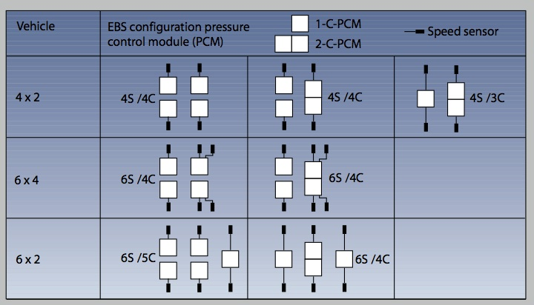

Figure 6 Summary of ABS configurations. These configurations also apply to systems to be described in following sections.

Trailers

2S/1M Two wheel ends are sensed and all wheels on the group are controlled. This scheme is sometimes used on steerable axles at the front of a trailer (or dolly trailer). The advantage is that there is no steering effect arising from modulation of the wheels on one side only. Consequently 2S/1M systems with a select-low strategy are used on steerable dolly axles.

The disadvantage of 2S/1M systems is that they ‘waste’ braking effort on roads with different friction levels on each side (so called “split-mu” roads). Wheels on both sides are controlled according to the low-friction side performance.

2S/1M systems are widely used on North American trailers (which tend to have bogie axles, both of which are controlled) and occassionally used in Australia. When used in Australia, 2S/1M ABS is applied to steerable dolly trailer axles.

2S/2M Commonly used on bi- and tri-axle axle groups. Occasionally used on dolly
(2S/2C) trailers. Commonly used on European tri-axle semi-trailers and Australian semi-trailers with a bi-axle rear group.

4S/2M Commonly used on semi-trailers. The front and the rear axles in the rear group are (4S/2C) sensed independently.

4S/3M The usual ‘dog’ trailer configuration. Rarely used on bi- or tri-axle semi-trailers.
(4S/3C)

6S/3M Is available although seldom used.
(6S/3C)

4S/4M 4S/4M is not currently used on Australian trailers.
(4S/4C)

A directly controlled wheel is one that is both sensed and controlled. An indirectly controlled wheel is controlled in response to sensing on another wheel in its group.

In most truck installations wheels on one axle only in a multi-axle group are sensed. ADR 38 requires that at least one axle in a single or tandem axle, and at least two axles in a tri-axle group are sensed. In contrast there are no configuration requirements for Antilock brakes on trucks.

During heavy braking some load transfers from rear axles to front axles. This effect is greatest when fully laden and when the centre of mass of the load is high. For a vehicle with front and rear axle groups, load transfer to the front group occurs irrespective of the suspension characteristics.

The same effect occurs in a brake-reactive suspension group. Usually, but not always, the front axle in the group experiences load increase and the rear axle load reduction during braking. Consequently the rear axle in the group is most likely to lock-up first. A notable exception is that trailing-arm spring suspensions, which are commonly used on Australian trailers, tend to transfer load backwards.

Brake-reactive suspensions experience substantial load transfer during heavy braking from one axle to another axle in the group. Airbag suspensions are assumed to be unreactive but in practice are just less reactive than mechanical spring suspensions. Stacked leaf and taper leaf suspensions are assumed to be brake reactive. The direction of load transfer within a group may be forward of backward depending upon the suspension design. If the suspension in the group is brake reactive the choice of the axle to be sensed will affect the stopping performance.

If the axle in the group that is most likely to lock-up during braking is sensed, then some braking effect will be ‘wasted’. The Antilock Brake System will control the other axle(s) as if it has the same wheel slip as the sensed wheel whereas it in fact has a lower slip. This scheme is called ‘sense low’. No wheels lock-up and tyre flat spotting is avoided.

If the axle in the group that is least likely to lock-up during braking is sensed, then wheel lock-up is likely to occur on the unsensed axle(s). This scheme is called ‘sense high’. There is no loss of stopping distance due to ABS modulation but there could be loss of transverse stabilizing forces. Tyre flat spotting could occur on a brake-reactive suspension. It is necessary to set-up the brakes appropriately to avoid flat spotting.

The usual approach for 4S/4M systems on bogie- and tri-axle groups is to sense the axle that is less likely to lock first. That is, the sense-high strategy is used.

2.5 International Perspective
ABS for commercial vehicles and trailers first became available in Europe in about 1981. European designed systems have evolved over thirty years to have a world-leading position.

Anti-lock brakes are mandated on new motor trucks and heavy trailers in the European Union, USA, Japan and Canada. Countries that have or are harmonizing their brake rules to UN ECE Regulation 13, such as China, India and South Africa, have or are in the process of mandating ABS as a consequence.

The European Union ABS requirement is in EU Directive 71/320/EC as subsequently amended. ABS has been mandated from 1991. Most Central European countries have harmonized their brake rules with ECE Regulation 13 since 2003, and hence have mandated ABS. It is also mandated on heavy trucks in Japan and South Korea.

European motor vehicles must have a minimum 4S/4M system. Semi-trailers must have an antilock system on at least one rear axle whilst full trailers must have antilock brakes on at least one front axle and one rear axle. 2S/1M systems are acceptable on semi-trailers.

The adoption of more stringent stopping distance requirements into the USA rule FMVSS 121 (1975) promoted the development for anti-lock brakes, mainly for drive wheel skid protection. Early USA systems proved to be unreliable and consequently ABS developed a bad reputation in North America, which has now been turned around. Antilock brakes have been mandated on heavy trucks and trailers in the USA and Canada from 1998.

2.6 Australian Applications
Australian ABS experience dates from 1986 (first B-Double installation). Trial ABS installations on triple road train were done in 1993 (with a special 24V power supply scheme).

ABS is mandated for all new B-double prime-movers by ADR 64. For all other vehicles ABS is optional. State road regulations require ABS on B-double trailers (but not single trailers) when they carry a dangerous goods placard.

NSW currently does not require ABS on prime-movers used in 19m B-double configuration. WA does not enforce the ABS requirement on in-service vehicles. State / Territory road agencies can require ABS to be fitted to B-double trucks that travel on particularly dangerous or steep roads.

Because ABS is mandated in Europe, Japan and North America, it is commonly found on new truck and buses in Australia. It is likely that more than 70% of new heavy motor vehicle sales have ABS installed.

ABS is commonly (if not universally) installed on new heavy omnibuses in Australia. This is not an ADR requirement.

ABS systems can be retrofitted onto prime movers and trailers. This is sometimes done to satisfy in-service B-Double requirements.

2.7 Technical Standards
Standards relevant to Anti-Lock Braking Systems in Europe, North America, Japan and Australia are applicable to systems installed in new vehicles and not to aftermarket ABS.

The National Heavy Vehicle Modification Code (VSB6) requires compliance of modified (retrofitted) vehicles to the applicable ADRs (35 and 38) at the time of manufacture. That is, performance is to be proven in specific vehicle models and the status of any approval is not necessarily applicable to installations in different vehicles. There is no Australian ‘approval status’ for off-the-shelf ABS systems.

Australia
When fitted to new heavy vehicles, an Antilock Brake System must comply with the design and performance requirements in ADR’s 35 and 38. These requirements have also been adopted by reference into the in-service rules. In summary these are:

- At least one axle in each axle group must remain unlocked (above 15 km/h speed) when a full-force brake application is made. The test, which must be conducted for motive trucks, is conducted in both laden and unladen states on a dry, sealed high-friction road surface

- A warning lamp must signal to the driver when there is a break in the electrical supply to the Anti-Lock Brakes on either the motor truck or the trailer(s). The warning lamps must be powered off a cabin supply that is unaffected.

- When an ABS electrical connector is provided on a towing vehicle it must be to DIN standard 72570 (12V) and ISO 7638:1996 (12V or 24V). The pin assignments are shown in Figure 7.

- The superseded brake rule ADR 35/01 required that when an ABS trailer connector was provided, the ECM and modulator power was 12V. To meet this, manufacturers of European and Japanese trucks (which have 24V electrical systems) provided an electronic step down unit for the Australian market. Australian trailer ABS applications are usually 12V.

- The test vehicle must be able to achieve the lightly laden partial failure performance levels with the ABS disabled. The levels are: 1.8 m/s² from 40 km/h for heavy goods vehicles and 2.10 m/s² from 60 km/h for heavy omnibuses. That is, less than half of the usual performance standard. Tests on split-coefficient surfaces are not required.

- In contrast heavy trailers must comply with the laden performance standard whether the ABS is working or not. Trailer compliance can be demonstrated by computation and this can assume that the ABS will not degrade stopping performance. That is, testing is not required.

- There is no requirement that the ABS have veto control over the operation of a powerful auxiliary brake. Most truck manufacturers do wire in this function. It may not be wired in on retrofit systems.

Brake systems on new Australian trailers are usually certified using approved sub-assemblies (foundation brakes, air-control system and suspension). ADR 38/03 does not require that ABS trailer performance be validated. That is ABS is ‘deemed’ to comply. Road testing of a truck ABS is needed to verify compliance with ADR 35/03.

The current brake rules (ADR’s 35/03 and 38/03) does not require that trailer ABS connectors have 12V power levels. The 12V requirement was dropped because most Electronically Controlled Brake Systems (which incorporate and ABS function) are 24V. 24V is a sensible voltage level for trailers (and particularly for multi-combination trailers) because it can deliver reasonable power levels without substantial voltage drop. However, Australian practice has been to use 12V trailer electrical systems.

All major trailer EBS manufacturers now offer 12V systems (or dual voltage capability). The dropping of a mandatory voltage interface standard will lead to some confusion over trailer voltage specification. Industry will need to develop solutions to this new potential incompatibility.

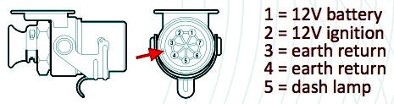

Figure 7 ISO 7638:1996 terminal (12V) arrangements. For a 24V system the terminal `assignments are the same but the mechanical keying of the plug and socket are different than for a 12V system. (Courtesy Airbrake Corporation)

Pins 6 & 7 are used for CAN bus communication on higher-level systems. The 5-pin and 7- pin connectors have the same keying. Different keying is used for different voltage (power) levels.

Some systems can operate off ‘multi-voltage’. That is, 12V or 24V. Two keyways might be provided that allows connection to either a 12V or a 24V towing vehicle.

The trailer warning lamp function is achieved by two methods. Firstly, the trailer ABS can activate an in-cabin warning lamp by connecting pin 5 in the trailer ABS connector to 0V. This method is mandated by the Australian Design Rules (35 & 38). Only one trailer warning-lamp need be provided on the truck in multi-trailer applications.

Secondly, some prime-mover installations have a ‘trailer module’ that monitors the current drawn on pin 2 of the trailer connector and assesses whether the trailer ABS is drawing a current in the normal range. If not, the trailer warning-lamp is illuminated. This method is optional.

There is no legal requirement to provide a trailer ABS connector on a truck or trailer that has an ABS system.

Europe
The Anti-Lock Brake technical standards are in Annex 13 of UN ECE regulation 13. The test performance standards that are required are more stringent than in the Australian design rule standards. European rules require demonstration of ‘split-mu’ performance for some vehicle categories. Furthermore, a friction utilization of 75% of peak friction must be achieved on a sealed test roadway.

Five categories are identified:

Category 1 – An Antilock system for a motive truck with ‘split-mu’ capability that meets the
prescribed performance levels. Heavy trucks and buses with not more than four axles must have Category 1 ABS.
Category 2 - An Antilock system for a motive truck with split-mu’ capability.
This system meets lesser performance levels than a category 1 system.
Category 3 – An Antilock system for a motive truck without ‘split-mu’ capability.
Category A – A trailer ABS system with ‘split-mu’ capability. Heavy semi-trailers must have a
Category A Antilock system.
Category B - A trailer system without ‘split-mu’ capability. Rigid drawbar, dog trailers and light
trailers must (at least) have a category B Antilock system.

A ‘split-mu’ system is designed to operate with different friction levels on each side of the vehicle. It always has independent modulation on each side of the controlled axles. Therefore, Category 1, 2 and A systems must have an even number of modulators (2, 4 or 6); that is, independent modulators on each controlled axle end.

In summary the European Antilock test requirements concern:
- Reliable operation with prolonged brake applications
- Adequate performance on a ‘split-coefficient’ surface. Stoping tests are conducted on a surface having different friction levels on the left and right sides of nominal 0.7 and 0.3.
- An average friction utilization on each surface of 75% is required.
- The laden vehicle must demonstrate an average friction utilization of at least 75% on a dry sealed road.
- The Antilock system must have control over any a regenerative braking system.

North America
Straight-line and ‘braking-in-a-curve’ testing are prescribed for new heavy vehicles (which must have an ABS fitted). For the braking-in-a-curve test, the vehicle is braked from an initial speed of 48 km/h (30 mph) on a wet surface (friction level 0.5) with a radius of curvature of 152m (500ft). The testing is conducted both laden and unladen. The vehicle must stop within a (3.6m) 12ft lane.

In the EU countries, USA and Canada, ABS is mandated on new vehicles (including trailers) and cannot be legally disabled.

2.9 Maintenance
All installations have a fault warning-lamp. This signals the driver when the ECM detects faults (such as low speed signal levels or sluggish modulation valve operation). A blink code scheme is usually implemented to identify the precise fault.

Common problems are: Wheel speed sensors out of adjustment.
Wiring faults – broken wiring or poor connections.

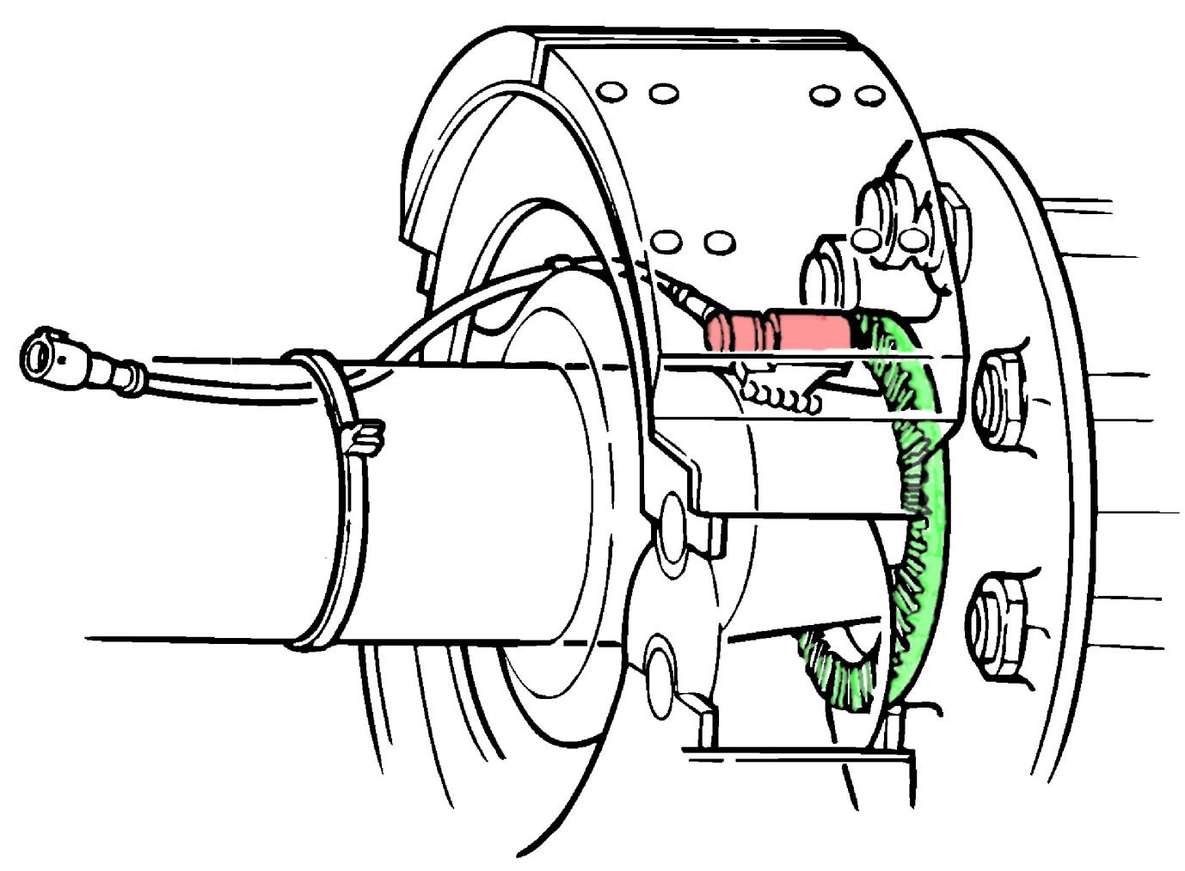

Figure 8 ABS wheel pole ring and wheel speed sensor installation on a drum brake.
(Courtesy Airbrake Corporation)
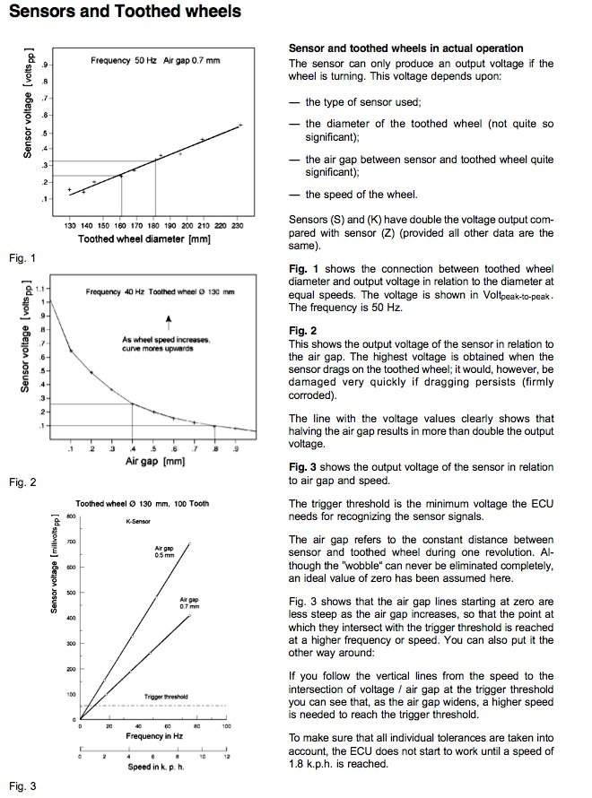
Figure 9 ABS wheel speed sensor signal levels. (Courtesy Airbrake Corporation)

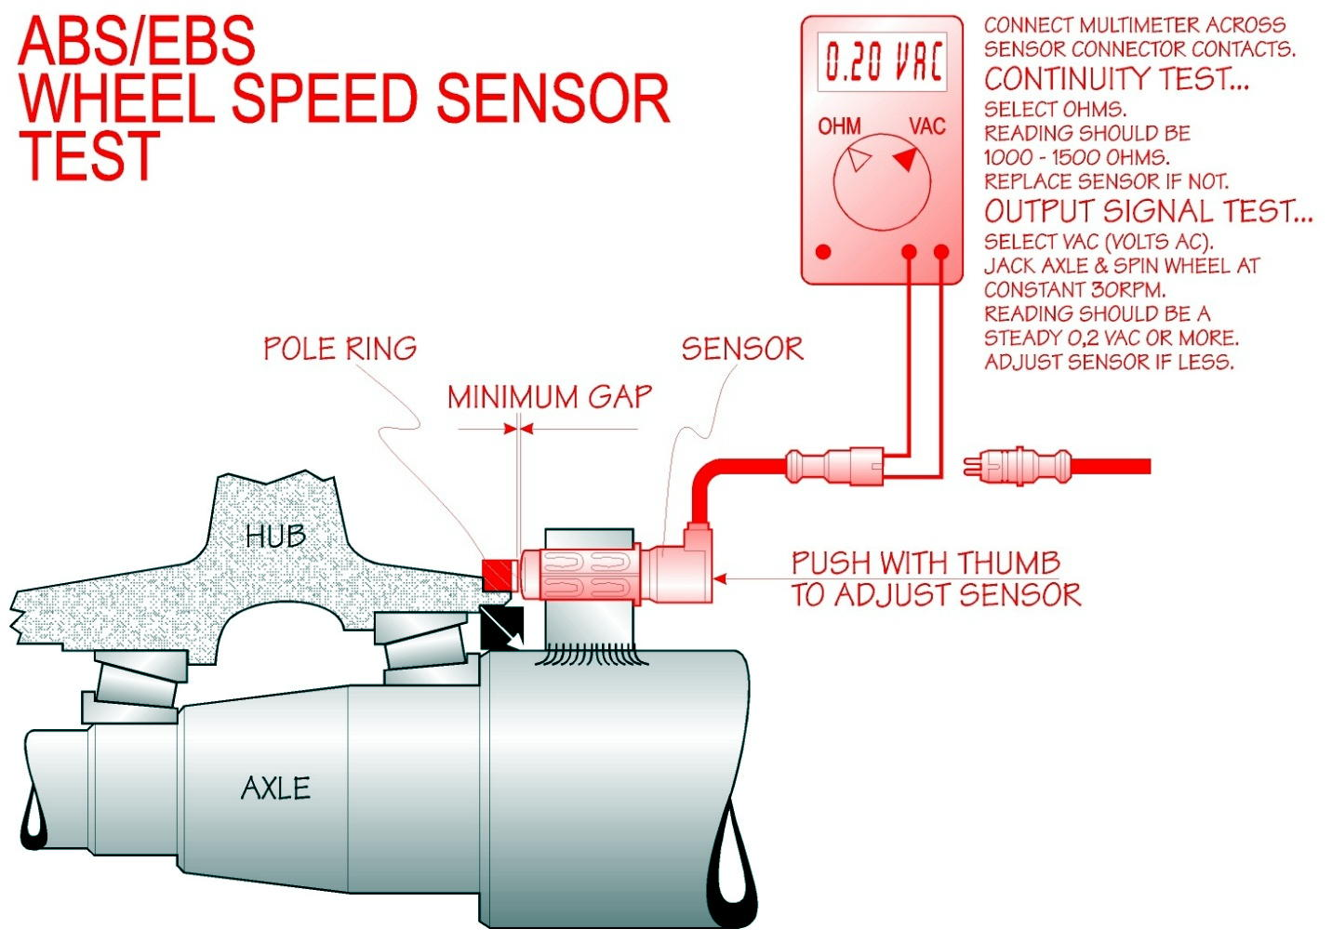

Figure 10 ABS wheel speed sensor signal checks. (Courtesy Airbrake Corporation)

In the usual installation the magnetic pick-up speed sensor is retained in a cylindrical ‘spring liner’. When the sensor is pushed against the pole ring and released, the pushes back about 0.5mm. The sensor location should therefore be designed into an accessible location.

2.10 Features and Limitations

ABS will reduce brake pressure on wheels when wheel slip is pending or actual. The modulation cycle causes a temporary reduction of braking effort on the controlled wheel(s). On a loose or slippery surface the stopping distance may be increased by multiple modulation cycles, particularly if they are widespread and frequent.

The duration of the modulation cycle depends upon the time needed to release and then reapply the brakes. This increases with the capacity of the brake actuators. Because disc brakes typically have smaller actuators than drum brakes they are advantageous.

Automatic brake adjusters are advisable because they minimize the distance the brakes need to move and thereby speed up the modulation cycle. Automatic brake adjustment is standard with disc brakes but not with drum brakes. There is no Australian requirement to use automatic brake adjusters with ABS.

Modern ABS holds pressure build up before pressure venting. Modulation may not occur unless the vehicle has a propensity to lock-up wheels. However, it is possible that a (combination) vehicle with poor brake balance will experience frequent brake modulation with some loss of potential stopping performance. In this case ABS is still advantageous because the driver will need to apply the brakes very cautiously in the absence ABS to keep the vehicle directionally stable.

Many ABS systems have an ‘off-road’ mode in which the controller is more tolerant of pending lock-up and has a lower modulation cycle frequency. This mode is useful on loose-surface roads such as gravel or snow covered pavements, and grass. The usual ‘off-road’ scheme is that temporary wheel locking is allowed in the speed range 15 – 40 km/h. Above 40 km/h ABS operation is the same as for the ‘on-road’ mode. Below 15 km/h there is no ABS action in either condition. A warning lamp illuminates when ‘off-road’ mode is active. The ‘off-road’ mode is cancelled when the ignition switch is turned off.

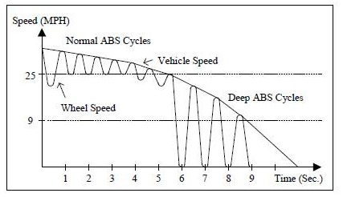
Speed Km/h
40
15
Deep ABS cycles –
‘off-road’ mode
Figure 11 Illustration of ‘off-road’ Antilock operation. (Courtesy Knorr-Bremse)

In countries where ABS is not mandated, a switch can be fitted that disables ABS operation. This condition is indicated by a slow flashing ABS warning light.

Most ABS systems have an auxiliary-brake control electrical contact. This contact opens to disable auxiliary brake system (such as an engine brake or retarder) operation when the ABS is modulating any of the wheels. Because auxiliary brakes usually operate on the drive axle(s), the auxiliary brake effort compounds the service brake effort. By disabling the auxiliary brake the ABS can more easily reduce drive-wheel slip. Use of this feature is not mandated in the design rules.

Some ABS systems now have ‘drag-torque control’. The ABS requests that the engine retarder via the CAN bus to reduce its torque level to prevent developing wheel slip arising from engine or auxiliary brake action.

During ABS ‘modulation’ the ECM broadcasts status information according to the AES J1939 protocols onto a CAN bus

Electrical supply limitations may exist on multiple-trailer vehicles. Most trailer systems are 12V. The modulation valve solenoid current is typically 2A. If several valves operate simultaneously then voltages drops will occur, particularly on long trailer connections. Current 2S/2M trailer systems typically draw 5A – 7A when modulating the wheels. However, technical developments are reducing these current draw levels.

Whilst operation on 12V B-Doubles is apparently acceptable, this may not be true for road-trains or B-Triples unless battery or super-capacitor storage is provided on trailers. 24V operation is a more sensible level for multi-combination vehicles.

Because previous versions of ADRs 35 and 38 have mandated 12V control and modulation valve voltages at the trailer coupling, most Australian trailer ABS installations are 12V (as distinct from 24V). On European motive trucks the 12V ABS supply is usually obtained from an electronic voltage reducer. Note that this probably produces 24V until it is loaded at which time the voltage reduced to 12V. Therefore voltage tests must be done on a loaded system.

Earlier versions of the Australian design rules required the ABS supply voltage to be 12V at the coupling interface. Vehicle manufacturers with 24V systems met this requirement by fitting an electronic step-down unit. Whilst this no longer required, truck manufacturers and operators need to consider the backward compatibility of new installations. Furthermore some ABS systems are now multi-volt.

The modulation cycle time has an important influence on stopping distance. During the pressure release phase the braking effort is reduced. Whilst the utilization of the available road friction is enhanced during the hold phase, air-brake systems invariably have a longer cycle times that ABS on hydraulic brake systems because the air brake actuators need to be recharged.

Under some truck failure conditions one or both ‘diagonals’ will be disabled. For example, the front right and left-rear modulators are disabled in the event modulators at either of these positions are assessed to be faulty. Similarly, the front left and right rear modulators are disabled should a fault exist with the components on this diagonal. On a trailer, if the ABS controller detects a fault, the ABS function may be suspended.

Whilst 4S/4M motive truck ABS systems still use a diagonal split, fault tolerance is much improved compared to earlier systems. Some types of faults will not disable the diagonal – for example, a single sensor failure will only affect the wheel/s at that corner and not diagonally opposite.

Experience is that the gap between the wheel speed sensor and the pole-ring sometimes get out of adjustment. The sensors need to be positioned less than 1mm from the pole ring. Bearing end-float is the most frequent cause of sensor adjustment problems. Extreme road vibration might also cause sensor out-of-adjustment and hence low signal level.

Wheel speed sensor repositioning is simply done pushing the sensor in using a blank rod. Manufacturers should position the sensor to allow easy access from the rear. ABS sensors should always be adjusted at the conclusion of hub or brake maintenance.

A persistent ABS warning signal may indicate excessive bearing wear or poor bearing adjustment.

If one of the two diagonals is disabled because of faults, the ABS performance may be substandard. Current-generation systems have more sophisticated fault diagnosis and performance during faults than older systems.

ABS has the advantage that it works with all types of suspensions – both spring and air. It does not require a weight signal because there are no set-point changes dependent on the loading condition of the vehicle.

Another ABS advantage is that it can be installed on any combination vehicle without affecting normal braking levels. No co-ordination or communication is needed between vehicles. ABS will always improve vehicle stability.

The claims made for ABS are that it:
- Prevents wheel lock-up under heavy braking and thereby improves vehicle stability.
- Facilitates vehicle steering during heavy braking.
- Reduces tyre wear (flat spotting).
- Reduces crash rate by preventing direction instability during braking.

3 Automatic Traction Control

3.1 Common Names
'ATC' - Automatic Traction Control (applicable to powered vehicles only).

'ASR' and 'DSC' in Europe. ASR was is translated from the original German wording as
Anti Spin Regulation for English markets.

‘DSC’ for Drive Slip Control.

‘TCS’ – Traction Control System – is used in North America.

‘TC’ – Traction Control

3.2 Function
Automatic Traction Control acts to control drive wheel slip under tractive effort. It does this in two ways. Firstly applying the brakes on one or both sides of the drive axle group to stop wheel slip. Secondly if the wheel slip is prevalent on both sides of the vehicle, the ATC instructs the engine to reduce its torque level.

ATC is an additional function with ABS and is applicable to motive trucks. It was first introduced around 1986.

In the usual Australian configuration ATC autonomously applies individual drive-wheel brakes (i.e. differentially) to prevent wheel slip under tractive effort. Thereby the drive wheel on the other end of the axle can get traction. ATC configurations exist that can only apply both drive wheel brakes coincidentally.

ATC also communicates with the engine controller via the truck data bus to request power / torque limitation when pending drive wheel slip (on sensed wheels) under tractive effort is sensed. This feature is active above about 2 km/h.

ATC may also monitor throttle position to predict when loss-of-traction is likely to occur.

In the usual arrangement ATC only applies the service brakes when the vehicle speed is less than 20 km/h.

3.3 Components
ATC has an electronic control unit that incorporates the ABS functionality and adds traction control capability. The latter is effected with extra electro-pneumatic pressure control valves in the rear brake circuit to enable application of drive wheel brake(s) without driver input.

Figure 12 shows the scheme with a single ATC valve installed in the control line. This scheme can only apply all the drive-wheel brakes. If separate ATC valves are used the brake pressures on each side can be independently controlled.

The ABS electro-pneumatic pressure control valves can be separate from the ATC pressure modules. However, current generation systems are trending to integrate the ATC and ABS modulation functions into one valve. Hence independent side-side control is commonly used.

In this paper an ABS modulator than can also apply the brakes is termed an actuating modulator.

Additionally, ATC has a data link to the engine control unit for engine speed/torque control. This usually applies the SAE J1939 communication protocol.

An information lamp activates when ATC action is occurring.
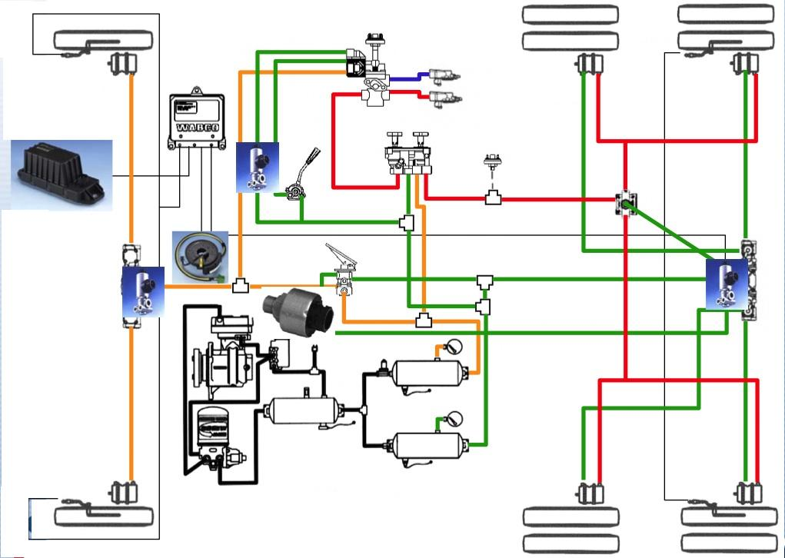

Figure 12 One manufacturer’s ATC scheme. A single ATC valve is used in the control line. This scheme applies brakes on both sides of the drive axle group. The ABS modulator valves then hold the pressure on the side without wheel spin and modulated pressure on the side with wheel spin. (Courtesy Wabco)

3.4 Configurations

ATC is typically used with two ABS modulation valves and four sensors on the drive group. That is, the normal configuration is 6S/4M. However, if the ATC valve is installed into the control line to the drive axle group, ATC is compatible with any of the ABS configurations.

The advanced brake control systems 13-18 to be described in later sections are autonomous systems. That is, capable of applying the service (and auxiliary) brakes autonomously. These systems incorporate actuating modulators and hence may also be capable of ATC.

Four drive wheel sensors are recommended for a bogie drive-axle group because the select-low sensor position is appropriate for ABS whereas the select-high position is appropriate for ATC. If only two drive wheel sensors are available (as on a 4S/4M system) then the performance of ATC on a reactive suspension will be less than desirable.

3.5 International Perspective
ATC is available as an option with most ABS systems applicable to heavy motor vehicles.

3.6 Australian Requirements
There are no Australian requirements to install ATC.

3.7 Technical Standards
There are no technical standards or regulations applicable to ATC in the European, USA or Australian vehicle regulations.

SAE information document J2564 Automotive Stability Enhancement Systems describes the features of ATC systems, without prescribing technical performance requirements.

3.8 Features and Limitations
In standard configuration, ATC only controls the service brakes for speeds below 20 km/h. The engine torque level may be controlled across a wider speed range.

The response time for ATC operation is about 1s. ATC is applicable to relatively low speed loss- -of-traction events on the sensed drive wheels. The cycle time is too long for ATC to respond to momentary loss-of-traction events on rutted or variable road surfaces.

ATC can only respond to wheel slip on the sensed wheels. If the un-sensed wheels in the drive axle group are on a local loose surface and consequently spinning, there will be no ATC intervention. A 6S/6M system provides optimal ABS and ATC performance.

Engine torque control is activated separately from the differential brake action. The ECM assesses when the truck is driving through curves and does not initiate differential brake control in this situation.

Some ATC systems provide a ‘loose-surface’ mode. This is typically only active below ~ 40km/h. The ‘loose-surface’ mode improves performance on very loose surfaces including deep snow. The engine control speed threshold can be changed from 2 km/h to 10 km/h by a switch control. A slow blinking warning lamp indicates to the driver that the system is in ‘loose surface’ mode. This mode is selected by the driver via a control switch.

Current generation ATC has advanced engine torque control that is applicable to straight-road driving and driving through curves and moderate speeds. The engine control function is active when the average drive wheel slip under tractive effort is assessed to be too high on the slip curve. This might occur when the vehicle is on a slippery road with equal wheel conditions on each side.

A warning lamp at the driving console lights when either differential braking or engine torque control are active. CAN bus messages using the J1939 protocol, are also broadcast.

3.9 Australian Applications
Automatic Traction Control (ATC) is readily available as an option with ABS for heavy trucks in Australia. It is commonly used on dangerous-good hauling prime-movers.

ATC (in conjunction with ABS) can be retrofitted to in-service vehicles.

4 Drag Torque Control

4.1 Common Name
'DTC' - Drag Torque Control (applicable to powered vehicles only).

4.2 Function
Increases engine traction torque (by fuelling the engine) to prevent wheel slip arising from engine compression drag force.

Some implementations will also instruct the retarder controller to disable the auxiliary brake.

4.3 Components
DTC uses the wheel slip information to predict pending drive wheel slip due to engine torque input. This assessment is made by the Electronic Control Module (ECM).

DTC requests a change in engine torque level by communicating via the CAN bus.

DTC is always implemented with ABS. However ABS may not have the DTC functionality.
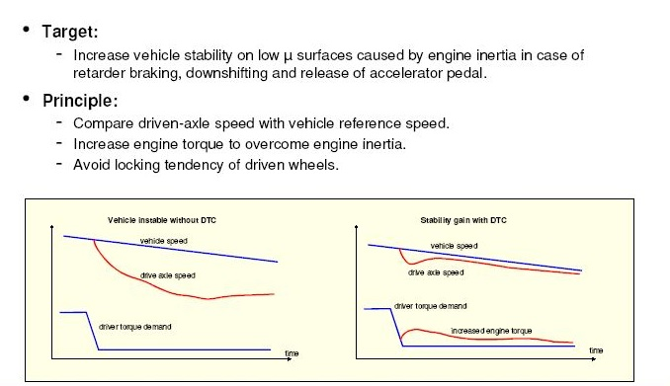

Figure 13 Illustration of the DTC operating principal (Courtesy Knorr Brense)

4.4 International Perspective
DTC is available as an option with some Automatic Traction Control (ATC) systems.

4.5 Australian Requirements
There are no Australian requirements to install DTC.

4.6 Technical Standards
There are no technical standards or regulations applicable to DTC in the European, USA or Australian vehicle regulations.

  - Features and Limitations
The wheel sensors should be installed on the rear axle most likely to lock under braking (i.e. the select-low’ strategy). This is usually the rearmost axle.

DTC acts to prevent jack-knife (extreme oversteer) arising from drive-train (engine, transmission and differentials) inertia. Such dramatic events are only likely to occur on slippery roads.

DTC together with ABS provides protection against the sudden and unwise application of auxiliary brakes.

DTC eliminates axle hopping on bob-tail prime-movers (i.e. trucks without a trailer).

4.8 Australian Applications
DTC is available in the Australian marketplace as an added feature on some ABS and ATC systems.

5 Electronic Brake (Force) Distribution

5.1 Common Names
‘EBD’ – Electronic Brake Distribution
‘EBSS’ – Electronic Brake Safety Systems (has features including EBD)

5.2 Function

EBD improves the brake-balance between the front and the rear-axle groups of a motive truck by distributing the braking effort for the two axle groups to produce a similar level of wheel slip on each sensed axle. It reduces the brake effort to the rear axle group in a controlled way. The front-axle group brake level is not altered.

EBD acts by reducing the brake pressure to the rear axle group compared to the front axle group.

Assuming that all the sensed wheels experience a similar level of road friction and have the same tyre characteristics, the wheel slip variations provide a measure of relative braking effort. The friction utilization (braking coefficient) of a lightly-laden axle tends to be high and hence the slip will be relatively high. The wheel slip can be reduced by reducing the brake torque on the lightly-laden axle group.

EBD does not attempt to control the trailer control air level (Trailer Response Management TRM) as it has no information about the trailer brake performance.

EBD is not applicable to semi-trailers as there is only one axle group. It is a function of Trailer EBS used on trailers with two axle groups (i.e. dog trailers).

5.3 Components
The ECM implements the brake distribution function by varying the electrical control signal level to the ABS modulators or relay valves. No additional hardware is necessary.

EBD is available on some advanced Antilock brake systems. It can be implemented with standard ABS modulators with intelligent control to extend the standard ABS functionality. The build-up of brake pressure can be controlled to prevent normal brake-pressure levels being achieved.

EBD functionality is a standard feature of Electronically Controlled Brake Systems (EBS), which is common on European trucks. EBS varies the brake level to the rear group via electronic control of relay valves.

EBD is a function of the EBSS brake systems that are available on Australian Kenworth models. These use a Knorr Bremse advanced Antilock brake system. The EBD functionality is applicable for brake control pressures up to 2.5 Bar. Above this pressure level operation reverts to the standard Antilock function.

The EBD communication between the ECM and the modulators (or relay valves) is via electrical communication.

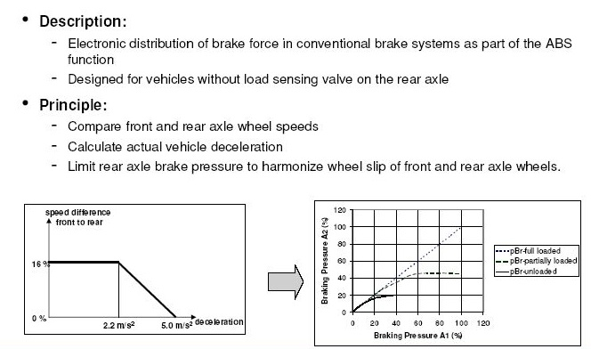

Figure 14 Illustration of the EBD operating principle (Courtesy Knorr Bremse).

5.4 Configurations
EBD is offered as an extension of ABS. The configuration is the same as that of the ABS. In most Australian cases a 4S/4M configuration is used.

5.5 International Perspective
EBD has been developed as an alternative approach to using mechanical load-sensing brake valves (although it can be used with a load-proportioned brake system). EBD acts to keep the wheel slips on the sensed axles at about the same level.

EBD is not used on North American trucks apparently because it is incompatible with the USA brake rule FMVSS 121. Apparently this rule limits the extent of difference that can occur between the application pressure on different axles.

Continental European heavy vehicles usually have load-sensing brakes. Additionally European EBS systems (see next section) implement the EBD function.

5.6 Australian Requirements
None.

5.7 Technical Standards
There are no national or international standards for EBD.

Features and Limitations
EBD operates using wheel speed sensor information only. It does not receive information about the load on the vehicle.

As EBD attempts to balance the wheel slip speeds on different groups, it is applicable to vehicles with multiple axle groups.

In effect, EBD is a quasi-load sensing system. As the underlying brake power is generally specified based on the static laden axle weights, wheel slip at laden steer and drive wheels should be roughly equal. Any difference beyond a tolerance range can be inferred as caused by a load differential, which can be calculated off the slip differential. The brake force (pressure) of the rear axle group is reduced accordingly.

Change of tyre diameter, particularly if it occurs on some but not all axle groups, will degrade EBD performance. The EBD controller must be set for particular tyre sizes.

If one brake pneumatic circuit fails, the EBD may reduce the braking effort on the active circuit. EBD will attempt to increase the brake pressure on the failed circuit without effect.

The EBD function is adjustable at the vehicle OEM or brake OEM level. The adjustment takes the form of the level of wheel slip variation that is acceptable between the sensed wheels on the front and rear axle groups. Wheel slip differences between sides of the same axle are not controlled. Rather, EBS is sensitive to the average wheel slip on each axle group.

5.9 Australian Applications
EBD is available on one North American make that is sold in Australia and one Australian make.

6 Trailer Response Management

6.1 Common Names
‘TRM’ – Trailer Response Management
‘CFC’ – Coupling Force Control
‘TFC’ – Trailer Force Control
‘TRS’ – Trailer Response Signalling

6.2 Function
Trailer response management exists at two levels:

Low-Level TRM is called Trailer Response Signalling (TRS). It converts the trailer air control signal from a towing vehicle into a CAN message. It does not alter the control level and does not implement Coupling Force Control.

High-Level TRM is called Coupling Force Control (CFC). It sets the brake signal level at the trailer coupling on the towing vehicle according calculations so as to achieve improved vehicle compatibility brake balance. The trailer brake level will in general be different to that of the towing vehicle brake level. The signal to the trailer is usually both an air pressure signal and a CAN signal. That is, CFC includes trailer response Signalling.

Coupling Force Control (CFC) accounts for the programmed trailer characteristics and the known features of the vehicle. It is a standard feature of an Electronically Controlled Brake System (EBS) used on trucks. The parameters of CFC can be varied using a service tool. The CFC function on Japanese trucks with EBS may be disabled.

EBS systems on European trucks implement Coupling Force Control. Australian trucks with EBD implement Trailer Response Signalling but not CFC. Trailers with EBS do not implement CFC for following trailers but do implement TRS.

Trailer Response Signalling speeds up the brake application on a combination vehicle.

6.3 Components
For EBS, the trailer control module sets the trailer signal air pressure under instruction from the electronic control module (EBS - ECM). The ECM sends the CAN message that describes the trailer signal level.

For Trailer Response Signalling a module (TRS CAN module) is installed that has at least one pressure transducer and a CAN transmitter. A second pressure transducer may be used for redundancy.

6.4 International Perspective
Coupling Force Control is a standard feature on European EBS. It is not a feature of antilock brakes or trailer EBS.

Trailer Response Signalling is a feature on EBD systems being marketed in Australia. It is applicable to markets where non-EBS towing vehicles are used in conjunction with Trailer EBS.

6.5 Australian Requirements
TRS is not mandated. The brake compatibility performance limits in ADRs 35 and 38 are referenced to the trailer control coupling on the towing vehicle. This is the point at which pneumatic pressure is to be measured. A system that alters the control air pressure during braking may affect the ADR compliance status of the vehicle. Coupling Force Control does this. Usually the coupling air pressure will be set before the test starts when ADR 35 and 38 compatibility tests are done.

The provision of both a CAN signal and a pneumatic control level to the towed vehicle allows for different brake instructions to be given to a purely pneumatic trailer control system compared to an electronic trailer control system. Some EBS implementations look for a trailer CAN acknowledgement and will alter the CFC levels depending on whether the trailer is assessed to have an EBS system or not. It is assumed that a trailer that gives CAN acknowledgement has trailer EBS set to comply with the UN ECE R13 unladen compatibility limits.

The ISO CAN standard 11898 has recently been amended to allow for multiple trailer CAN addresses so that different trailers can be addressed.

6.6 Technical Standards
The CAN bus standard (ISO 11992) is applicable Trailer Response Signalling (TRS). The signal protocol is usually in accordance with SAE 1939.

There are no national or international standards applicable to Coupling Force Control (CFC).

6.7 Features and Limitations
Trailer Response Signalling is used to speed up the brake response of a trailer brake system (when the truck has EBS or ESC).

Coupling Force Control operates for an assumed trailer brake response. It does not know the trailer weight level but infers it from the known towing-vehicle rear axle load. European EBS systems are programmed to assume that the trailer complies with the UN ECE R13 unladen compatibility limits, which is often not the case.

6.8 Australian Applications
Coupling Force Control is a standard feature of European EBS systems for trucks, but not a feature of Japanese trucks with EBS.

Trailer Response Signalling is an option with EBD truck installations in Australia. It is a standard feature of truck EBS systems.

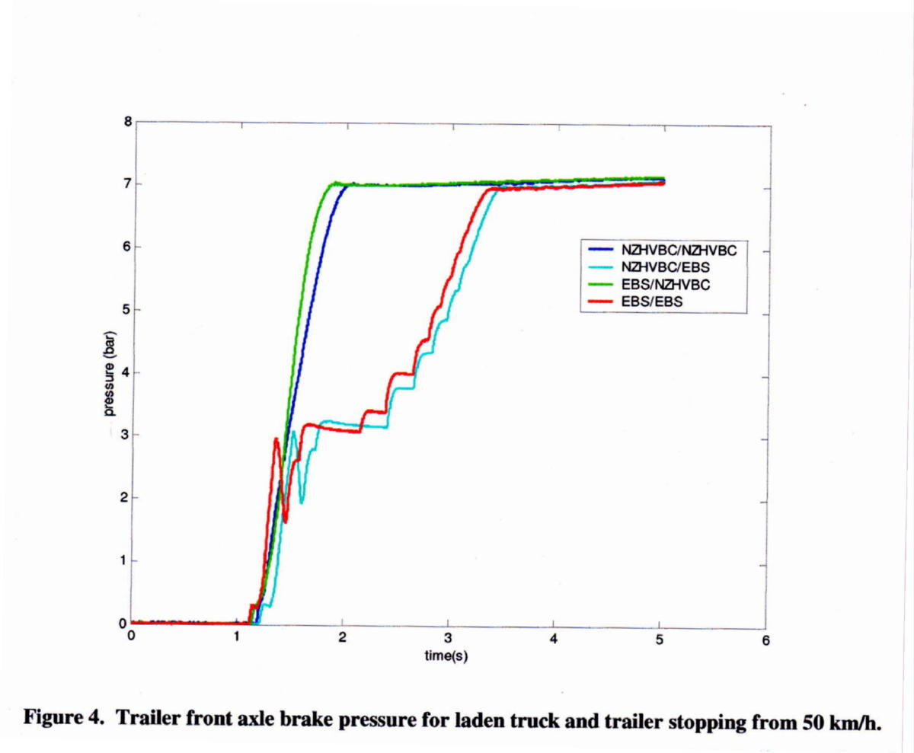
A pressure record for the front trailer brake pressure on a rigid truck with a dog trailer. The truck has EBS which can be enabled or disabled. When the truck EBS is enabled, it applies Trailer Force Control to achieve the desired deceleration-time profile.

From de Pont et.el (TERNZ Ltd – New Zealand), Compatibility of Heavy Vehicle Brake Systems.

7 Electronically (Controlled) Brake System

7.1 Common Names
‘EBS' Term widely used and recognized for Electronic Braking System on trucks only; not trailers. For trailers see the next section, Trailer EBS.

Also known as 'EBP' (Electro-Pneumatic Braking) by Mercedes Benz, and 'ECBS' (Electronically Controlled Braking System) in the US.

7.2 Function
EBS manages the distribution of the braking effort between axle groups and sets the trailer brake control line pressure. That is, EBS attempts to improve the use of the available road friction by managing brake balance on both the motive truck and on the truck-trailer combination.

EBS has an electronic control system that manages and supervises the pneumatic system. ‘Proportional’ relay valves are used that have an electronic control feature. The EBS determines the air pressure to be applied to the brakes on each axle. If the electronic system fails the pneumatic control system continues to operate without the intelligent brake distribution.

The communication between the electronic sensors (including the brake pedal position sensor), the ECM and the electric-over-air relay valves is normally via an electronic data bus (usually a CAN bus). Pneumatic control signals are also used as a back-up.

The defining feature of EBS is electronic communication between braking control elements via a CAN bus.

EBS always incorporates ABS and EBD functions. If the truck has a trailer coupling, the EBS can be set to have TRM (Trailer Force Control) functions.

7.3 Components
EBS uses the same wheel speed sensors as ABS, a brake pedal position sensor, an advanced electronic control unit, and electro-pneumatic pressure control valves (as well as several pressure sensors integrated with various EBS components).

The brake pedal valve (usually) produces two air control pressures and an electrical signal level. Other inputs are the wheel speed signals and the brake-wear level signals. Some systems have a single pneumatic circuit. The electronic control is primary and a single pneumatic circuit is used as a secondary (fault) signal.

EBS for commercial vehicles was first introduced on the Mercedes Benz Actros in Europe in about 1996.

EBS uses compressed air as the energy storage and brake actuation medium, but virtually all control functions previously provided by pneumatic circuits are supplanted by electronic control. This is defining feature of EBS - the control signal from the foot pedal to the electro-pneumatic pressure control valves over the axles is electronic rather than pneumatic, providing much faster, more responsive brake application and release, although EBS provides many more features and advantages than this alone.

Note that current generation EBS still retains the conventional pneumatic control elements as a backup against electrical/electronic failure, but future development is expected to gradually displace much of the pneumatics from the cab environment).

EBS for towing vehicles usually includes a dedicated CAN data bus connection for communication with Trailer EBS, alongside the conventional pneumatic control signal. The CAN bus enables faster trailer brake application and release, along with co-ordinating communication between the truck and trailer. However, this is not the defining feature of EBS on towing vehicles as EBS will control the pneumatic control signal in the absence of the CAN bus.

Towing vehicles that provide an EBS connector for the trailer will have a 7-pin ISO connector. The additional two pins compared to the ABS connector are the CAN bus pins.
Many rigid trucks and buses are now equipped with EBS, which usually do not have a trailer CAN connection.

EBS alone cannot autonomously apply brakes.

Two pneumatic circuits (front/steer and rear/drive) are required by the design rules. The electronic control system need not be duplicated. The EBS configuration is sometimes referred to as ‘2P/1E’.
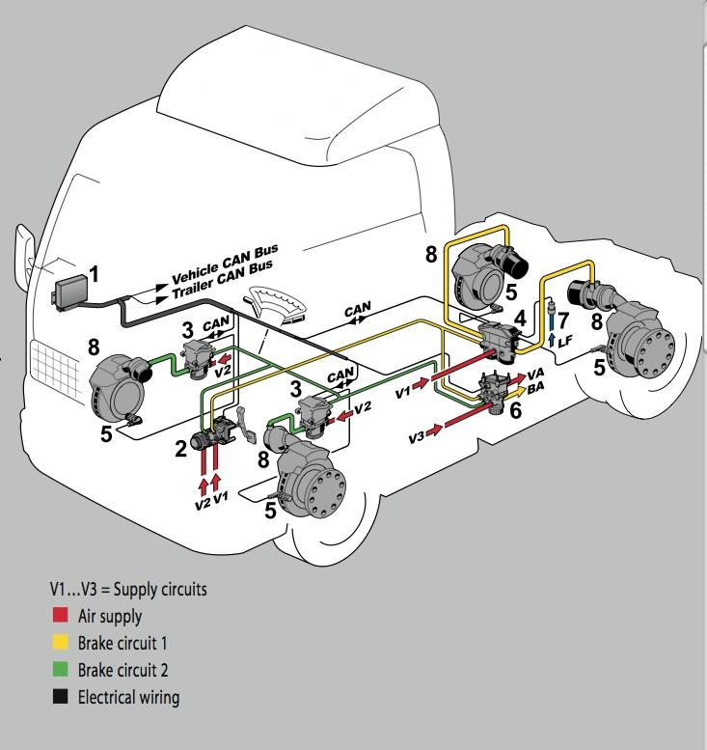

Figure 15 The EBS (4S/4M) scheme on a 4 x 2 prime-mover. (Courtesy Knorr Bremse)

1 Electronic Control Modules (EBS unit)
- Dual circuit pneumatic foot pedal control valve with electronic position sensing
- Front circuit electric-over-air modulation and control valve. This has a relaying function.
- Rear circuit electric-over-air modulation and control valve with ATC capability and relaying function.
- Wheel speed sensors.
- Electric-over-air trailer control relay valve.
- Pressure sensor in air bag system. Load sensor.
- Disc brakes.

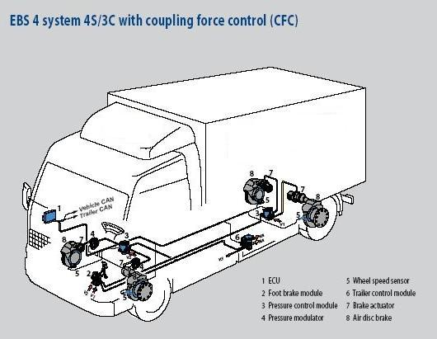

Figure 16 The EBS (4S/3M) scheme on a 4 x 2 rigid truck with a trailer coupling.
(Courtesy Knorr Bremse)

EBS will usually have lining wear sensors on the sensed wheels. The ECM can report the lining wear levels to a diagnostic tool. The EBS may also warn the driver when a lining on a sensed wheel reaches the 20% level.

EBS may incorporate brake temperature sensors to monitor brake effort on the various sensed wheels. A warning can be given to the driver if excessive brake temperatures occur.

EBS will warn the driver if the deceleration performance is unexpectedly low considering the brake pedal position (i.e. the demanded brake level).

Coupling Force Control is provided by the trailer control valve (Item 6). The EBS estimates the necessary trailer air control pressure level considering the weight of the load and the recent deceleration experience.

The European EBS systems are set assuming that the trailer complies with the compatibility limits in ECE R13 / EU 78/310 compatibility limits in all states of loading. This set-up can be changed by the truck manufacturer.

‘Start assist’ is usually provided. The brakes are applied briefly when the vehicle is stationary. This prevents roll-back if the vehicle moves from stop on a hill.

EBS often has an “in-shot” feature. The trailer control line is charged rapidly by a sharp injection of air pressure. The in-shot level can be set in the range 0- 3.5Bar. If the truck and trailer both have EBS (and are communicating via the CAN bus) the in-shot feature is suppressed.

EBS has a controllable trailer threshold level. That is, the braking level on the truck at which the trailer is instructed to start braking can be altered by set-up. For example, the air pressure in the truck’s rear brake circuit at which the trailer control line receives air pressure might be altered in the range 0 – 1 Bar. Truck manufacturers use different threshold pressure set-ups in the Australian marketplace. Part 1 of this Code recommends design threshold pressure levels.

In the usual European implementation, an EBS motive truck will have an air-bag rear suspension and disc brakes. EBS obtains its estimate of the load on the truck via a pressure sensor (Item 7) in one of the airbags. A weight estimate might also be obtained from the position of the load-sensing lever on spring suspended trucks or even from the measured acceleration under known torque.

Current generation EBS for powered vehicles does not rely on the measured load via pressure sensor or spring deflection. It uses wheel slip differential between steer and drive wheels to estimate drive axle load. This is effective for any suspension type assuming that the tyres are identical on each axle. Additionally the acceleration performance for the known engine torque can be used for confirmation.

If the actuator size or lever lengths are changed then the EBS should be reprogrammed. The EBD strategy relies upon a correct set-up of the controller.

It is impractical to retrofit EBS to in-service motive trucks. Retrofit would require the complete brake control system to be replaced.

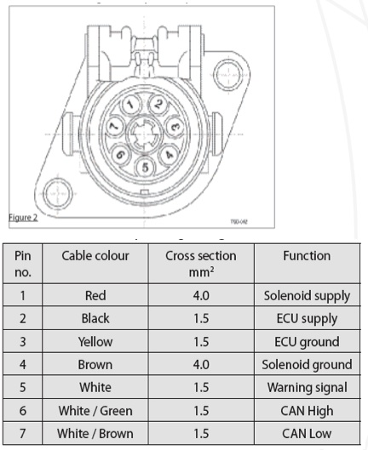
(Wire colours may vary)
Note the keying of the ISO 7638-1 and –2 connectors is different.

Figure 17 ISO 7638:1996 / 2003 pin arrangements
ISO 11992 is a fault tolerant physical CAN implementation for truck-trailer
communication.

The Australian voltage stipulation is in ADR 35/02:
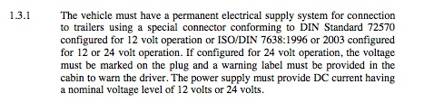
The ADR rule does not regulate the CAN voltage level. Trucks may have 12V power supplies with 24V CAN.

Because the ADR stipulation that ABS trailer connections must be supplied at 12V has been lifted, greater use of 24V trailer ABS and EBS systems without voltage changing is occurring. Compatibility considerations will ensure that 12V converters are used in many instances.

12V and 24V CAN signals cannot be intermixed. Note that 12V CAN communication between truck and trailer is not used in other parts of the world.

Multi-volt trailer EBS systems are now marketed in Australia. These can be powered at either 12V or 24V. Multi-volt systems assume that the CAN communication level is also at the supply voltage level. Therefore, the CAN should be supplied at the same voltage level as the supply voltage. If the CAN voltage is different to he supply voltage then ISO / DIN 7638 is not satisfied.

7.4 International Perspective
EBS has been developed in Europe and most installations use European manufactured EBS systems. EBS is now available in Australian on European and Japanese heavy trucks. It is not available on Australian or North American manufactured trucks.

EBS is commonly installed on European trucks. The majority of European motor trucks imported into Australia now have an EBS. EBS can be used with any rear suspension. If an air suspension is used, in most instances an airbag pressure signal will monitored by the EBS and used as a confirmation of the vehicle weight. If a spring rear suspension is used, the EBS will obtain an estimate of vehicle weight from the observed acceleration as a function of engine torque.

EBS is an optional system in Europe. The European brake regulations (EU Directive 71/320 and ECE regulation 13) do not require an EBS to be fitted. Only ABS is mandated.

7.5 Australian Experience
EBS is only available on European manufactured motor trucks and some Japanese prime movers.

EBS is not mandated in any Australian regulation. The fuel-haul industry has been a leading exponent of EBS and there is now a significant Australian experience of EBS on motive trucks and Trailer EBS.

European motive trucks that have EBS usually also have disc brakes.

7.6 Technical Standards
There are no specific Australian technical standards. There are no particular requirements in the Australian Design Rules concerning Trailer EBS or EBS except that a partial failure test is required for any ABS/EBS system. In the case of an ABS/EBS failure the vehicle must achieve a minimum of the secondary brake system performance. In practice the failure performance should be much better than the secondary level because both brake circuits should remain active.

7.7 Features and Limitations
EBS on European vehicles is apparently programmed so that the vehicle complies with both the laden and unladen compatibility limit curves in the European Union Directive 98/12/EEC (which is harmonized to UN ECE Regulation R13/09). Hence the towing vehicle EBS system will assume that the trailer complies with the compatibility limits by either having a load-sensing brake system or a trailer EBS.

Most Australian trailers do not have either load-sensing brakes or Trailer EBS. When the vehicle is lightly laden the prime-mover EBS is likely to over-drive the trailer brake pneumatic control line resulting in excessive wheel lock-up (assuming the trailer does not have an ABS / Trailer EBS). The trailer will be over braked. Australian operators with European EBS on the prime-mover and without Trailer EBS on the trailer can experience unacceptable trailer braking levels. Trailer ratio valves or load-sensing brakes can be fitted to correct the situation. Alternately the Trailer Force Control feature can be disabled by set-up.

If the trailer has an EBS (see Trailer EBS) then the towing and towed vehicles should be able to communicate via the CAN bus. If the CAN bus connections between prime-mover and trailer are electrically compatible, the control brake level is communicated electronically (instantaneously) to the trailer. An electrical incompatibly can occur if the truck has a 24V CAN system and the trailer a 12V CAN system.

If the CAN signal is not available, Trailer EBS will generate the control brake signal using a pressure sensor on the trailer. As the pneumatic signal is being relied upon for signalling between truck and trailer, an additional time delay occurs.

When the principal method of communication between the ECM and the relay valves is electronic, the response time of an EBS brake system is shorter than that of the pneumatic brake system. For a B-Double truck the time taken for the trailers to achieve full pressure braking will be about half the time taken by a purely pneumatic control system. Stoping distance from 100km/h is likely to be about 10m shorter on a B-Double with electronic signalling compared to a truck with pneumatic signalling.

In the presence of electrical failures the EBS will probably register a fault and suspend electrical control. The cabin warning lamp will be illuminated (assuming that a total electrical failure has not occurred). The base pneumatic brake system will operate without any intelligent control.

If the wheel speed sensors are out-of-adjustment both the ABS and EBS functions will be suspended or restricted (on one or other diagonal).

EBS systems that have been available in Australia have not been capable of CAN communication with multiple trailers. This problem has now been solved. The CAN protocols have now been changed so that multiple trailers can be addressed. Some latest generation EBS systems now recognize the presence of a second trailer and account for the multiple combination of trailers. The CAN protocols have recently been

Current generation EBS systems assume that a single trailer with a load-sensing brake system is being towed. Next generation systems will be able to interrogate individual trailers and determine whether Trailer EBS is installed. The Coupling Force Control function may be either applied or disabled depending upon the assessed brake control features of the trailers. This will be a welcome development.

Added predominance, ratio or Williams valves in the pneumatic brake control circuit will only affect trailer EBS (Trailer EBS) performance if there is no CAN communication between the truck and trailer(s). The Trailer EBS is able to determine when a difference exists between the control air pressure and CAN control signal. The Trailer EBS is likely to respond to the CAN signal and log a fault code.

Use of ratio or predominance valves as an add on to truck EBS is sometimes done to prevent gross trailer wheel lock-up when vehicles are lightly laden. These valves should not be used when the trailer has Trailer EBS.

In all instances the truck EBS system has the master role. Trailer EBS does not instruct the truck EBS.

EBS Reprogramming of the vehicle set-up is needed when any of the following changes occur:
- Tyre rolling diameter.
- Wheelbase.
- Foundation brake size including actuator size.
- Type of truck body, which affects height and location of the centre of mass.
(EBS trucks usually have disc brakes)

The advantages claimed for EBS are:
- Faster application and release times.
- Improves the brake distribution between axle groups on the truck (EBD function).
- Steer and drive axle wear balancing.
- Can improve brake compatibility balance between the motor vehicle and the trailer (TRM function) if it is correctly set-up for the trailer.
- A suitable platform for the addition of vehicle stability controls.

The Australian limitations are:
- Performance limitations if the load signal (from the suspension) is wrong. This could occur if a load signal is derived from a deflection sensor on a spring suspension. Note however, most EBS systems proportion the brakes based on the relative speed values and this feature is independent of the load signal.
- EBS programming is not optimised for multiple trailer applications.
- Most Australian EBS set-ups assume that the trailer complies with the unladen characteristics in the European brake rule (ECE R13), which is usually not true in Australia. Hence the trailer control level is often too high. Whilst the set-up can be changed, the one set-up cannot be satisfactory for both an ECE R13 trailer and a standard Australian trailer (without EBS or load sensing brakes).
- EBS or load-sensing brakes.
- 12V and 24V truck-trailer connectors are not interchangeable.
- Only 24V EBS is available (i.e. for motive trucks). A 12V CAN bus is incompatible with a 24V CAN bus. {Australian hardware is now available that interfaces 24V and 12V CANs, so European EBS trucks can (and should) comply with ISO7638-2 with use of an adaptor}.
- Electrical failures will result in a loss of some or all EBS functionality. The pneumatic brake system will continue to operate without the added EBS brake management.
- Some European trucks have a shut-off valve installed in the trailer control line to prevent it being charged when the truck is parked. The truck routinely communicates its control level to a Trailer EBS. If the Trailer EBS sees a significant difference between the control air pressure being supplied and the communicated brake control level, a warning light will come on and a fault will be logged.

At least one Japanese vehicle that is marketed in Australia has an EBS that has been set-up for a typical Australian trailer (which does not have load sensing brakes or EBD).

One European truck EBS system in the Australian marketplace alters its characteristics depending upon whether a Trailer EBS trailer is connected to the CAN bus or not. This adds another level of sophistication. If the trailer is not communicating with the truck, the EBS can assume the trailer does not comply with the ECE unladen characteristics and alter the Trailer Force Control function accordingly.

Figure 18 shows the measured relative performance of a six-axle test semi-trailer with and without EBS and Trailer EBS. The EBS truck achieves a faster brake application (~ 0.2s advantage at reach 0.4g) and a higher steady deceleration (by about 0.13g).

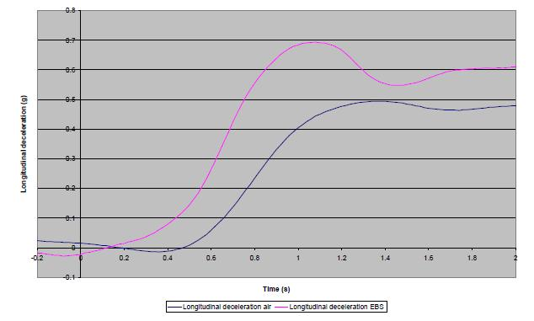

Figure 18 Comparison of deceleration with EBS enabled (top) and disabled (bottom) for a six-axle semi-trailer equipped with EBS on the prime-mover and trailer EBS on the trailer. (Acknowledgement: Transport Research Laboratory Ltd, UK).

7.8 EBS Programmability
Table 1 gives the programmable parameters for a leading brand of EBS. Changes to some parameters could potentially alter the certification status of the vehicle. Consequently EBS set-up changes can only be performed by the vehicle manufacturer or the EBS supplier. For in-service vehicles such set-up changes may require a formal assessment by a signatory engineer.

Parameter | Comments | Authority level
Vehicle type | Bus, rigid truck etc | Vehicle OEM, EBS supplier
Configuration | 4S/4M etc | Vehicle OEM, EBS supplier
ASR |  | Vehicle OEM, EBS supplier
ASR switch | Determines whether off-road mode is set | Vehicle OEM, EBS supplier
Wear control | True to activate wear balance control | Vehicle OEM, EBS supplier
Wear sensors fitted | True when sensors have been installed | Vehicle OEM, EBS supplier
Air pressure range | Information about maximum supply air pressure | Vehicle OEM, EBS supplier
Wear sensor display | Display can be activated | Vehicle OEM, EBS supplier
Wear sensor warning light check | If true the wear sensor warning light comes on at start-up. | Vehicle OEM, EBS supplier
Auxiliary brake cut-out relay | If true, the EBS will have veto control over the auxiliary brake. | Vehicle OEM, EBS supplier
Trailer control valve installed | Trailer line pressure is controlled | Vehicle OEM, EBS supplier
Tyre circumference | Specifies the tyre rolling radius. | Service agent.
ERE R13 Error Bit | Status bit set | Vehicle OEM, EBS supplier
Drag Torque Control | Activated or Deactivated | Service agent.
Extended ABS control | Changes the ABS setting | Service agent
Brake force distribution parameters AZ1, BV1 & RBV2, AV1, AV2, Retarder inclination, IG, ZsR, VsR | These nine parameters are used to set-up the brake force distribution on the vehicle model. | Vehicle OEM, EBS supplier
ASR active light control | Activated | Service Agent
Yellow warning light | Activated | Service Agent
Red warning light | Activated | Service Agent
‘Halt’ brakes | Safety interlock for working trucks | Service Agent
‘Halt’ brakes pressure level | Specifies the safety brake pressure level | Service Agent
‘Halt’ brake maximum speed | Speed switch level for safety brake | Service Agent
Differential ratio | Rear axle ratio | Service Agent
Threshold pressures | Of front, rear and an additional axle | Vehicle OEM, EBS supplier
SAE J1939 Monitoring | Selected data on the CAN bus is monitored | Vehicle OEM, EBS supplier
Repeat rate for ECB messaging | Three repeat rates can be selected | Vehicle OEM, EBS supplier
Pole ring teeth | Number of teeth is specified | Vehicle OEM, EBS supplier

Table 1 Programmable parameters for Wabco EBS.

A well-known European vehicle manufacturer can change the set-point brake distribution between the front and rear axle groups on a truck in the range 70% - 170% (ratio is: front axle brake pressure / rear axle brake pressure).

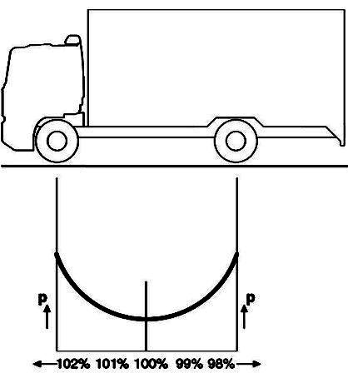
F/R can be adjusted in the range 70% - 170%
F
R
(a)
The brake compatibility balance set-point between the truck and trailer can be adjusted in the range 70% - 130% (ratio is: average truck group pressure / trailer control line pressure). The active brake distribution is managed around the set-points.
T/(1/2F + 1/2R) can be adjusted in the range 70% - 130%
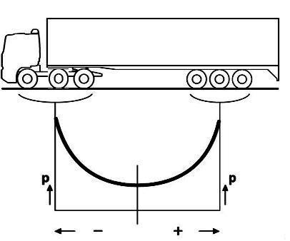
F+R
T

The brake compatibility distribution is managed around the above set-points. Additionally the predominance (which is an offset) to the trailer can be adjusted in the range -35 kPa to 50kpa.
(b)
Figure 19 (a) Illustration of distribution adjustment range for EBS on DAF Trucks.
(b) Illustration of compatibility adjustment range for EBS on DAF Trucks.

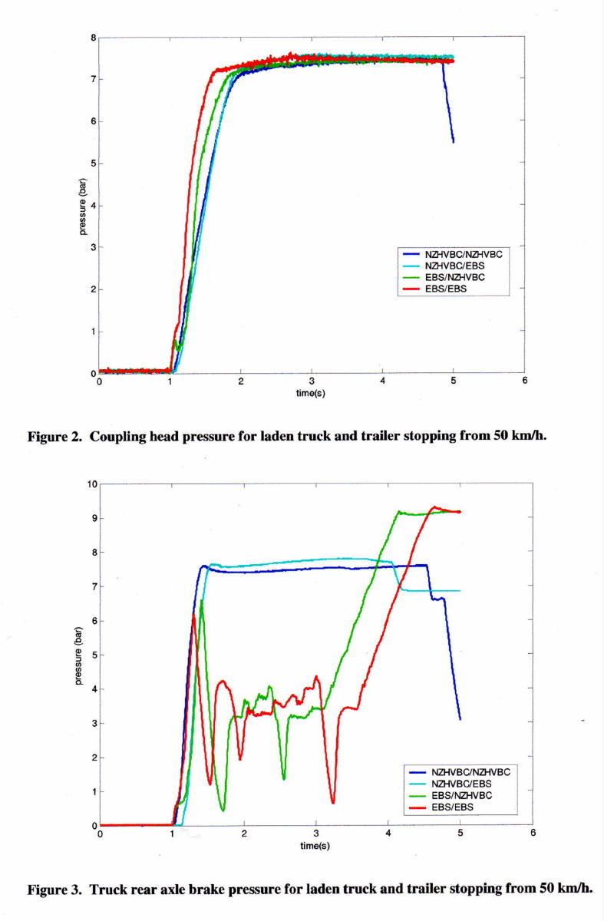

Interesting air-pressure recordings during a 50km/h hard stop with the driver applying constant brake pedal pressure. The two blue traces are for a truck with EBS disabled. The red and green traces are for the same truck with the EBS working. EBS actively manages the braking event by allowing, holding or releasing the rear brake actuator pressure to improve the distribution balance.

From, John de Pont et.el. (TERNZ Ltd, New Zealand) Compatibility of Heavy Vehicle Brake Systems

8 Trailer Electronically Controlled Brake System

8.1 Common Names
‘Trailer EBS’

'TEBS' - Term used and recognized for Trailer Electronic Braking System (to
differentiate it from the motive vehicle 'EBS').

8.2 Function
Trailer EBS manages the distribution of the braking effort between axle groups on one trailer. That is, it attempts to improve the use of the available road friction by managing brake balance.

Trailer EBS is the trailer version of EBS. A significant difference is that Trailer EBS does not attempt to control (i.e. alter) the pneumatic control signal to following trailers. This signal is passed through pneumatically or via a CAN bus.

Trailer EBS always has an anti-lock brake function and a load-sensing (brake balancing) function. It often incorporates a roll-stability function. These functions operate independently of the towing vehicle EBS (if it exists). Trailer EBS will operate effectively without a CAN signal from the towing vehicle.

All Trailer EBS incorporate a CAN interface. Trailer EBS generates an electrical signal for the incoming pneumatic control pressure using a pressure transducer. If a CAN signal is available it is used preferentially.

Unlike truck EBS, Trailer EBS does not attempt to alter the compatibility brake distribution on a vehicle. It passes the brake control signal through to following trailers unmodified. For a vehicle with both truck and Trailer EBS, the truck EBS is acts as the master, although truck EBS does not control the axle-level braking on trailers.

8.3 Components
Trailer EBS comprises the same wheel speed sensors as ABS, a more advanced electronic control unit, electro-pneumatic pressure control valves (usually integrated with the electronic control unit), and a number of pressure sensors (also usually integrated with the electronic control unit). Trailer EBS was first introduced in Europe around 1998.

Trailer EBS still uses compressed air as the energy storage and brake actuation medium. Trailer EBS is usually powered from the towing vehicle via a dedicated electrical connection. This is the same connection that has been used for many years for trailer ABS, so Trailer EBS may be powered by any ABS equipped towing vehicle with this trailer ABS power connection (providing the power supply voltage matches).

When powered, Trailer EBS may be triggered by either a conventional pneumatic control signal from a non-EBS towing vehicle, or an electronic signal on the CAN bus from an EBS towing vehicle.

Trailer EBS requires a power connection. If the trailer is coupled to a towing vehicle that has no ABS or EBS power plug, all electronic features may be disabled. An unpowered brake system operates purely in pneumatic mode with a conventional trailer air brake relay valve system.

In the absence of an EBS connector on the towing vehicle, Trailer EBS can be wired directly to an ignition controlled power circuit to the trailer. However, the design rules require that a fault circuit be provided so direct wiring does not comply with ADR 38. When no CAN bus signal is available Trailer EBS uses the incoming pneumatic control signal.

Some Trailer EBS systems may have a ‘stop light’ power mode, which provides some functionality when the brakes are applied. The electrical supply is taken from the stop light circuit. Care must be taken to provide adequate power capability in this instance.

Trailer EBS vehicles usual have a rear-axle air suspension and Trailer EBS will monitor trailer axle load by sensing air-bag air pressure.

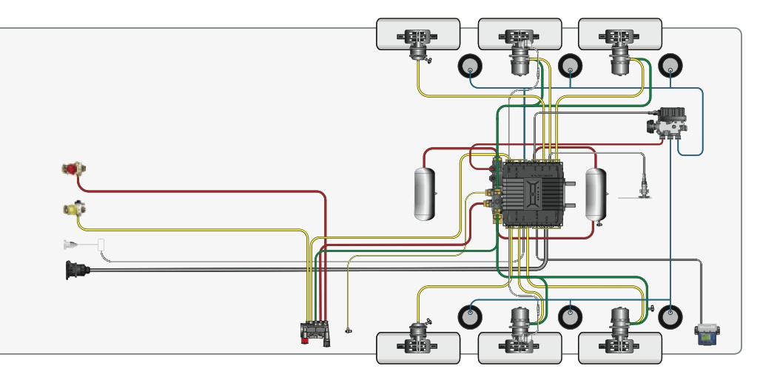

Figure 20 An integrated trailer EBS scheme.

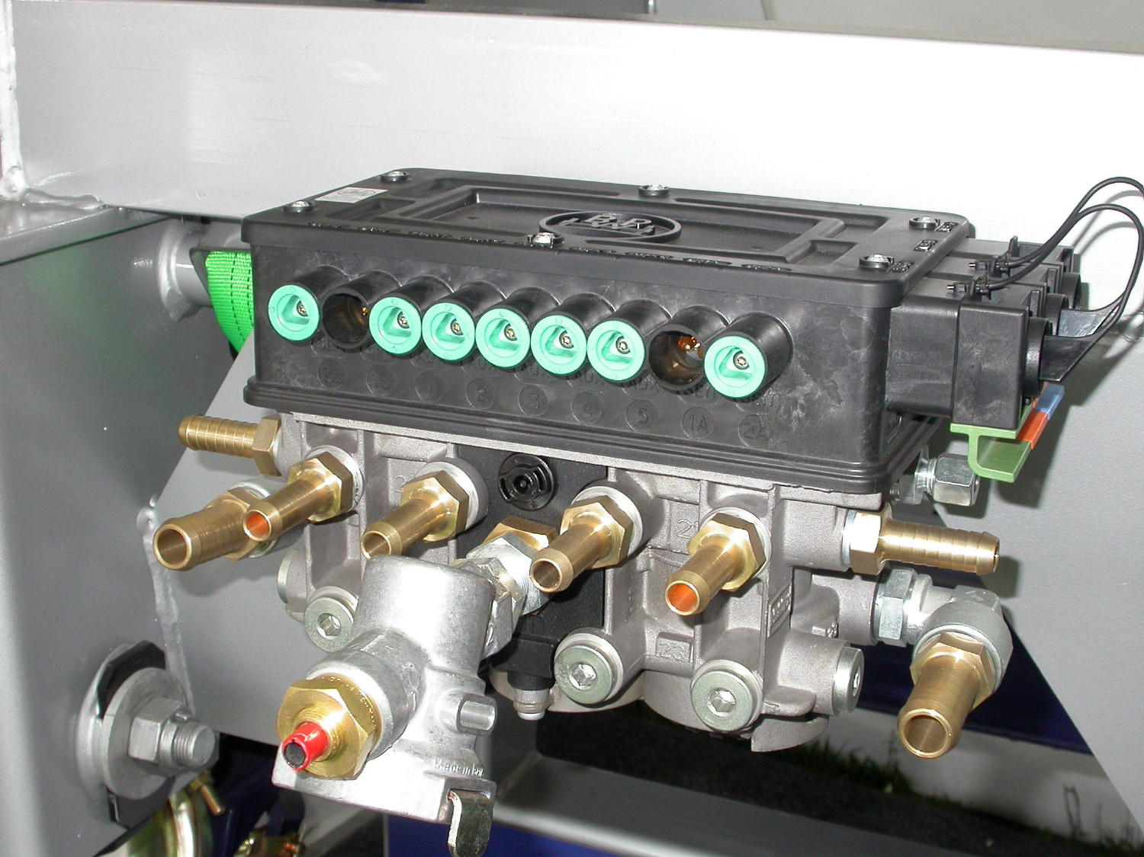

Figure 21 A trailer EBS control module, which is mounted on top of a dual relay valve module (Courtesy: BPW)

8.4 Configurations
The Trailer EBS configuration is usually 2S/2M and sometimes 4S/2M. 4S/3M is available for trailers with steerable axles (e.g. dog trailers).

8.5 International Perspective
Trailer EBS was released in Europe in 1998. Roll Stability (RSS) was added as a standard Trailer EBS feature in Europe in 2004.

8.6 Australian Requirements
There are no specific Australian technical standards. There are no particular requirements in the Australian Design Rules concerning Trailer EBS or EBS except that a partial failure test is required for any ABS system. Should the ABS (which is a feature of Trailer EBS and EBS) fail, the performance of the brake system must be at least that of the secondary brake system.

8.7 Technical Standards

There are no Australian technical standards. UN ECE Regulation 13 does have some requirements concerning the failure performance of electronically controlled braking systems.

8.8 Features and Limitations
The availability of CAN bus communication with an EBS on the towing vehicle will speed up the brake response.

In the absence of a CAN connection the Trailer EBS will operate using the control pressure signal presented to it. If any control valves are placed in the pneumatic system on the towing vehicle, such as predominance, ratio (such as Williams) valves etc, then the Trailer EBS will operate on an altered control level.

Trailer EBS receives the suspension pressure signal and uses this to estimate the load on the trailer. If a fault exists with this air signal, then the braking level is incorrectly set. In event of loss of signal due to holed suspension bellows, Trailer EBS will assume fully laden condition. There is no EBD function on Trailer EBS for a semi-trailer as there is only one axle group.

Trailer EBS cannot work in a co-ordinated way on multiple trailer trucks. Each Trailer EBS operates independently. This situation has recently changed with the introduction of new generation systems that work with multiple trailers.

There are currently no North American EBS or Trailer EBS systems. Therefore, Trailer EBS cannot communicate with an EBS on a North American type brake system because there are none. Some Japanese truck models EBS systems have recently been introduced in Australia as an option for new trucks. These have 24V trailer connections.

The first Australian Trailer EBS systems were 24V powered. A step-up unit was required on 12V motive vehicles. This situation has now changed as multi-voltage Trailer EBS has been released.

Trailer EBS operation may be limited on multi-trailer combinations. The current draw for a 12V system is in the range 7A - 10A per trailer. Voltage drop at the rear modulators can be excessive leading to poor modulation performance. As a guide a 12V Trailer EBS system is proven on two trailers but not three. Some suppliers have developed supplementary power modules for very long vehicles. A 24V Trailer EBS system has a lower current draw than a 12V system so multiple trailers can be satisfactorily supplied.

Trailer EBS systems are available that are tailored to particular types of trailers (tankers, flat decks, etc).

Some additional features that may be available within trailer EBS are:

- Integral data logging of distance, speed, axle load, ABS and RSS (roll stability) events.
- Console warning panel that reports landmark disc-pad wear levels, trailer air supply pressure, etc.
- Integration with speed-governed lift axle control.
- ‘Reset-to-Ride’ suspension function that will reset the suspension height to a preset level when the speed reaches a set-point.

100 %
Fully laden
Pressure to the Rear Brake Group
Incoming Trailer Air / Can Signal Level
1:1 line

Decreasing
load

Unladen

5 %
0 %
100 %
33 %
66 %
Incoming Trailer Air / Can Signal Level

Figure 22 Illustration of typical Trailer EBS pressure adjustments.

The set-points denoted by are programmable. The actual characteristic varies progressively between fully laden and unladen curves depending upon the load level that is estimated from the air-suspension pressure.

On some systems the breakpoints shown in Figure 22 can be set separately for the trailer axle group and for the through path to the following trailer.

One Australian supplier sets the threshold pressure (5%) level to +28 kPa (4 psi) if the trailer has disc brakes and +40kPa (6 psi) is the trailer has drum brakes.

8.9 Australian Applications
By 2010 there are estimated to be about 3000 Trailer EBS installations in Australia. The technology is now mature and much operational experience exists. The majority of these are 24V systems that are powered from a 12V:24V step up converter on the prime mover.

Most the Australian installations now have trailer Roll Stability (RSS) as a standard feature.

8.10 Maintenance and Diagnosis
Trailer EBS does not have a blink-code diagnosis capability. Diagnosis is via PC connection or optional on-board display modules. These are specific to each make of Trailer EBS.

Trailer EBS must be programmed for the particular types of valves and for the trailer dimensions and weight ratings. A placard should be affixed to the trailer that identifies what trailer settings (tyre size, actuator size, load sensing level...) have been programmed.

9 Roll Stability System

9.1 Common Names

‘RSS’ – Roll Stability System
‘RSP’ – Roll Stability Program
‘RSC’ – Roll Stability Control
‘TRSP’ – Trailer Roll Stability Program

9.2 Function
Applies selected brakes to reduce the risk of rollover occurring when a dangerous situation is sensed. The strategy is to reduce the speed of the vehicle in a controlled manner.

Some RSS systems apply all the brakes autonomously (i.e. without driver input). Other RSS systems apply selected brakes autonomously.

Roll stability capability on prime-movers and rigid trucks can be provided as a separate feature or as one element of Electronic Stability Control (ESC).

For trailers, RSS is usually an extension of Trailer EBS. It was first introduced around 2004. It is now a standard feature of Trailer EBS in Australia. Trailer RSS comprises an enhanced Trailer EBS electronic control unit with added integral lateral accelerometer(s) to measure the lateral cornering force on the trailer. The ECM uses the measured lateral acceleration and the instantaneous speed to predict a developing roll-over situation. Brake application occurs via the Trailer EBS pressure modulation valves.

Trailer RSS based on an ABS platform exists in North America but has not been used in Australia.

Trailers often roll-over before prime-movers do. Generally the trailer will experience higher peak lateral acceleration and is more prone to initiate the roll-over than the prime-mover. However, truck ESC may have better sensitivity to a developing roll-over situation than a trailer system, knows the intended steering position and slow the vehicle more effectively by applying the brakes on all vehicle parts. Therefore, ESC / RSS should be used consistently on all parts.

There is some potential benefit from using Trailer RSS on a semi-trailer in a road-train (A-trailer) configuration without having RSS on the dolly trailer. Because combinations tend to roll-over from the rear it is more important to have RSS on the semi-trailer than the dolly trailer.

When RSS determines that the trailer is in danger of rolling over, it applies maximum braking independent of any driver action in an attempt to slow the combination to below the rollover threshold speed.

RSS will operate without any CAN communication from the towing vehicle - it will function behind any towing vehicle that can provide it with a constant power supply (such as any ABS-equipped towing vehicle),

The rollover threshold of trailers vary with a number of factors such as load, load distribution, track width, suspension roll stiffness, height of centre of gravity, cornering speed, radius of bend, etc. Since these vary from trailer to trailer and trip to trip it is impossible to pre-program a rollover threshold into the RSS that will be appropriate in every situation.

All else being equal, a trailer with a very low centre of gravity will tolerate a higher lateral force than a trailer with a high centre of gravity, so the actual rollover force is not an accurate indicator of impending rollover. The most accurate indicator is the propensity of the inside wheels to lift off the ground. So, RSS detects when the inside wheels are close to leaving the ground. It does this as follows:

  - RSS measures the lateral acceleration (which translates to rollover force) via an integrated accelerometer. The RSS is pre-programmed to monitor for a pre-set lateral acceleration 'trigger' value (initially set to 0.25g each time the system is powered up). This value is deliberately conservative so that the RSS will react before any trailer is in danger of rollover (extensive testing has shown that virtually all modern trailers can sustain 0.25g without rollover).

  - When the 'trigger' lateral deceleration value is detected, the RSS begins a series of short, very low-pressure test brake applications. This is referred to as a 'level 1' RSS event. These 'test' brake pulses are usually so low and short as to be almost imperceptible to the driver. RSS as implemented with EBS can apply the brakes on each side independently.

  - As long as the lateral acceleration exceeds the 'trigger level', these test brake pulses continue. The purpose of these pulses is to brake the wheels to generate a wheel slip variation that the ECM can measure (from the wheel speed sensors). Some systems pulse- test all wheels and some only the wheels on the inside of the turn (which are travelling slower).

  - Because weight is being pushed from inside wheels to outside wheels by the cornering force (lateral acceleration), the inside wheels exhibit a higher wheel slip than the outside wheels. The RSS can use this wheel slip difference to calculate how much weight is being transferred, and from this it can determine almost exactly when the inside wheels are no longer supporting any weight and therefore are on the point of leaving the ground.

  - The RSS will amend the ‘trigger level’ over time based on assessment of ‘level 1’ performance. That is, RSS estimates the roll-over threshold of the vehicle. When the ignition is turned on a low roll-over threshold is assumed. This is amended up or down based on the recent experience of vehicle performance. If the vehicle load level (as indicated by changes in the air-suspension pressure) changes significantly, the system will reset the trigger level and relearn the vehicle performance.

  - When the RSS detects that the inside wheels are substantially unloaded, it initiates a 'level 2' RSS event, which applies maximum brake pressure to all trailer wheels to slow the combination down as fast as possible. When this occurs the driver will be aware that the RSS is active. The braking action occurs when the RSS detects there is a real and imminent danger of rollover.

  - Note that the inside wheels will do very little of this braking because they are carrying very little weight, and would normally lock under a full pressure brake application, but the integral ABS function of RSS controls the brake pressure to prevent wheel lock. However, because the ABS controls left and right wheels independently in what is known as a 'split-mu' configuration, it can apply maximum braking to the outside wheels carrying all the weight whilst still modulating the inside wheels to prevent wheel lock.

If the 'level 1' test pulses do not result in a wheel slip difference that indicates an impending rollover, a 'level 2' event will not occur. The ECU 'learns' from this that the initial 'trigger' value is too conservative for the particular trailer and loading condition. The ECU adjusts the trigger level upwards a little so that the next time the trailer goes around a corner the RSS will not trigger the test pulses until a slightly higher lateral acceleration value is detected. This is the adaptive nature of the RSS control.

Each 'level 1' event that does not result in a 'level 2' response will cause the 'trigger' value to be increased slightly until a 'level 2' event occurs, at which point the 'trigger' value is fixed (slightly below this level) until conditions change. If the trailer loading changes (as indicated by the monitoring rear-axle air bag pressure) or if the RSS is powered down, the 'trigger' value is reset to the initial value again (usually 0.25g), and the process repeats.

RSS may also test pulse the brake system after the ignition is turned on to explore the extent of wheel slip for low-speed turns. It uses this information to set the initial ‘level 1’ setting.

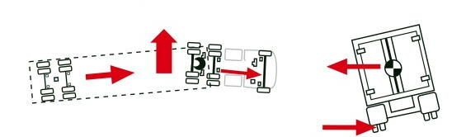

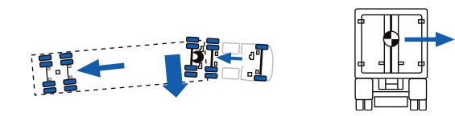

Figure 3 (a) Pending rollover due to excessive cornering speed.
- System response is to slow the vehicle by applying all the service brakes.

The system that is illustrated has RSS on both vehicle parts. In many instances RSS is on the trailer only.

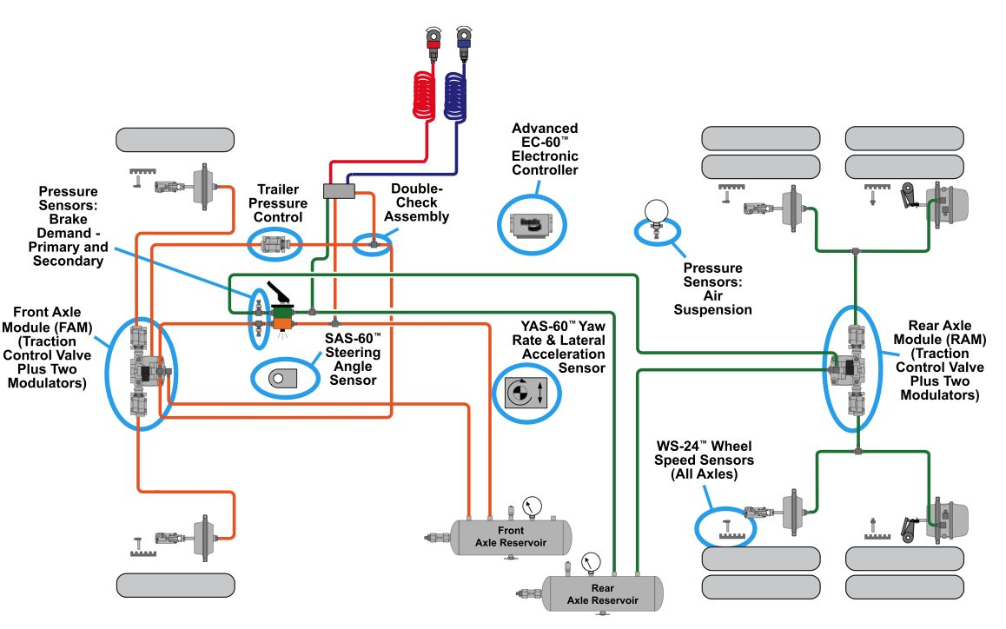Figure 24 Roll stability scheme for a North American prime-mover.

The lateral forces during to cornering that act on a vehicle are proportional to speed² / corner radius. Excessive speed and sharp changes of the steering wheel greatly affect the cornering forces.

9.3 Components
The roll stability functionality is an upgrade to ABS. It is usually incorporated with EBS but could be a separate system.

RSS incorporates a lateral accelerometer into the Electronic Control Module. Hence the ECM is different from that of the base platform.

9.4 Configurations
RSS is always used in conjunction with an ABS system. Because RSS implements independent side-side wheel control, the ABS must have a split-coefficient capability. That is, an even number of modulators must be used.

Tri-axle semi-trailer ABS configuration can be 4S/2M or 2S/2M.
The usual configuration for tandem or single-axle group trailers is 2S/2M.
The usual dog trailer ABS configuration is 4S/3M.

Some RSS models may apply test pulses to the steerable axle on a dog trailer and others do not.

9.5 International Perspective
RSS is not mandated at present in any country. The pending addition of vehicle stability requirements into ECE Regulation 13 and also into European Union Directive 71/320 will require roll-over stability functionality.

9.6 Australian Applications
RSS has been available in the Australian market since 2003-04. Significant experience of RSS has occurred in the bulk tanker segment of the transport industry. Typically new trailers that carry milk, wine or petroleum will now have RSS.

Some drivers complain that the RSS is unnecessarily slowing them down. For RSS to be slowing down the vehicle, ‘level 2’ RSS events must have occurred. That is the driver has been operating the vehicle close to roll-over and within the RSS safety-margin. Experienced drivers sometimes operate vehicles close to roll-over limits and relatively small changes to loading, speed or corner radius occasionally result in roll-over.

9.7 Technical Standards
There are no national or international roll-over technical standards for heavy vehicles. Global Technical Standard (GTR8) Electronic Stability Systems has aspects concerned with vehicle roll-stability. This rule is applicable to light vehicles.

9.8 Features and Limitations
Roll-over protection is effective on both the truck and the trailer of a semi-trailer combination even though the trailer may have a greater propensity to roll-over. Trailer RSS can be applied without the towing vehicle having RSS. Truck RSS cannot sense the trailer differential wheel speeds but does monitor steering wheel position and truck lateral acceleration. Truck RSS can apply all vehicle brakes to rapidly slow the vehicle down.

Inappropriate speed is often a dominant factor in truck and trailer roll-overs. Low road friction is usually a minor factor. Sudden sharp changes of steering wheel position result in substantial reduction in the cornering radius which greatly increases lateral acceleration.

RSS may apply the brakes prematurely when the vehicle corners on a poor quality surface because it assumes that the tyre-friction levels on both sides of the trailer are about the same. If one side of the road has a low friction coefficient then the wheel slip testing will be affected and the system may judge that the vehicle is turning when it is not.

The yaw acceleration information comes from a yaw sensor. If the road has side-to-side undulations then a yaw acceleration signal will occur that does not represent turning or banking action. The brakes might be applied incorrectly.

Poor wheel speed signals cause a loss of ABS functionality on one diagonal. RSS will operate with vehicle speed estimated from the remaining speed signals. The lateral acceleration sensor will operate independently of the ABS functions. Therefore RSS is tolerant to a loss of one speed signal.

When used on multi-combinations, RSS should be used on all the trailers or at least on the rear trailer(s). If RSS is only used on a forward trailer but not on follower trailers, there may be a tendency for the rear trailers to over-ride or push the trailer that is being braked (i.e. the trailer with RSS). This is potentially destabilizing. Furthermore, combinations tend to rollover from the rear. That is the rear of the trailer combination tends to be the least stable element.

Trailer RSS cannot prevent all trailer rollovers. It acts to slow down the vehicle when the vehicle is assessed to be in an unsafe operation domain. If the speed is excessive, the RSS action may not be sufficient to prevent the rollover.

9.9 Australian Applications
The roll stability function has now been incorporated into Trailer EBS on all current Australian-marketed systems.

10 Electronic Stability Control

10.1 Common Names

‘ESC’ – Electronic Stability Control (powered vehicles)
‘ESP’ – Electronic Stability Program
‘ESS’ - Electronic Stability System
‘DSC’ - Dynamic Stability Control
‘VCC’ - Vehicle Dynamic Control
‘VSS’ - Vehicle Stability System

10.2 Function
Counteracts potential loss-off-control movements on a motive truck by applying selected brakes. That is, it can correct understeer, oversteer and pending roll-over.

ESC includes the roll-stability capabilities of Roll Stability System (RSS) and Automatic Traction Control (ATC). It adds lateral (directional) stability control.

ESC can be coupled with either an ABS or EBS system.

ESC applies individual service brakes in each axle group autonomously.

10.3 Components
ESC applies selected brakes to achieve improved vehicle stability. It comprises:
- an enhanced ABS / EBS electronic control unit,
- separate ESC electronic control unit linked to ABS / EBS unit via SAE J1939/CAN bus,
- extra sensors (steering angle sensor to measure driver input, yaw and lateral acceleration sensors integrated into ESC electronic unit and working with ABS / EBS wheel speed sensors to measure actual vehicle,
- in the case of ESC on an ABS platform, additional electro-pneumatic pressure control valves to enable the system to initiate brake applications at any wheel without driver input.

ESC detects when the vehicle is deviating from the driver's desired course (e.g.: understeer or oversteer) and applies braking to selected wheels to correct the deviation.

ESC can also detect when the vehicle is in danger of rollover due to excessive cornering speed, and will apply maximum braking independent of driver in an attempt to slow the vehicle below the rollover threshold speed.

The system compares the demanded steering input (from the SAS) with the actual dynamic performance (from the yaw sensor).

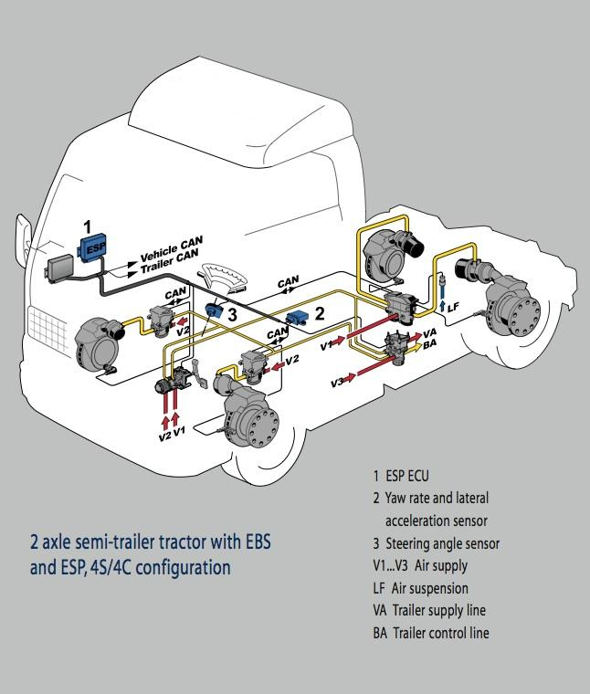
Figure 25 Electronic Stability Control scheme.

The scheme of ESC is similar to that of EBS with additional functionality and sensors as identified in Figure 25.

10.4 Configurations
As for ABS. In the usual configuration for a 4x2 or 6x4 motive truck, a 4S/4M system is used.

10.5 International Perspective
Electronic Stability Control was first introduced in Europe in 2001. Electronic stability control is being mandated on European motor trucks and trailers progressively from 2011. Applicable standards are under development.

The USA National Highway Safety Administration has announced its intention to mandate ESC on cars and light trucks (with GVM up to 10,000 lb – 4.5t) from 2011.

The technical standards for ESC on heavy vehicles are in initial stages of development by Working Group 29 of the UN ECE and have not been reflected in technical rules at this time. The UN ECE has developed Global Technical Rule 8 for ESC on light vehicles.

ESC is now an option on many European motive trucks. It is offered as an option on some North American ABS systems. That is, North American systems add ESC to an ABS platform (without CAN communication) or Electronic Brake Distribution. In Australia ESC can be specified on an ABS/EBD platform.

10.6 Australian Requirements
There are no ADR or Australian Standards requirements.

10.7 Technical Standards
It is notable that the UN ECE has released a Global Technical Standard (GTR8) Electronic Stability Systems, concerning the performance of passenger car ESC. The US rule is to be based on GTR8.

The technical standards for ESC on heavy vehicles will be included in the UN ECE Regulation 13, series 11 amendments. In summary a vehicle stability system shall include as least the following functionality:

(a) The ability to control engine power;

(b) In the case of directional control: The determination of actual vehicle behaviour from values of yaw rate, lateral accelerations, wheel speeds and the driver’s control inputs to braking, steering and engine. Only on-board generated information shall be used. If the signals are not directly measured then the evidence of the appropriate correlation with directly measured values under all driving conditions (e.g. including driving in a tunnel) shall be shown to the technical service at the time of type approval

- In the case of roll-over control: The determination of actual vehicle behaviour from values of the vertical force on the tyre(s) (or at least lateral acceleration and wheel speeds) and from the driver’s control inputs to the brake system and to the engine. Only on-bard generated information shall be used. If the signals are not directly measured then the evidence of the appropriate correlation with directly measured values under all driving conditions (e.g. including driving in a tunnel) shall be shown to the technical service at the time of type approval.

- In the case of a towing vehicle equipped according to paragraph 5.1.3.1* of this Regulation: The ability to apply the service brakes of the trailer via the respective control line(s) independently of the driver.”

* The connections of the compressed air braking system.

10.8 Limitations on Performance
ESC has a limited speed range in which it can be effective. Excessive speed in certain manoeuvres may cause un-correctable dynamics.

Because of its sensitivity and its ability to monitor steering direction, ESC on a truck may be able to sense a developing roll-over situation earlier in some situations than a Trailer RSS system. In particular ESC gets a steering control position input. However, truck ESC does not monitor the trailer wheel speeds and is insensitive to the trailer condition.

ESC does not receive information about instability from trailer RSS systems. The truck ESC will however anticipate that the speed is too high for the nature of the particular vehicle and act early to reduce speed.

In a multi-combination vehicle, the truck ESC may not be able to sense the roll propensity or dynamic condition of the trailers at the back.

It is advisable to have an antilock brake function on the trailer(s) pulled by an ESC truck. ESC operation will usually pressurized the trailer brake control line. If the trailer has no wheel lock-up protection then trailer lock-up and possible swing could occur.

ESC is able to deal with poor dynamics arising from sudden changes in road friction levels.

10.9 Australian Applications
Whilst ESC is being used on heavy trucks in Australia, only preliminary experience exists.

11 Adaptive Cruise Control

11.1 Common Names

‘ACC’ - Adaptive Cruise Control
‘ACB’ – Active Cruise with Brakes
Proximity Control
Adaptive Cruise Control is one element of a Driver Assistance System (DAS)

11.2 Function
ACC monitors the space immediately in front of the truck using radar sensors. It acts in four ways to maintain a safe headway in front.

The four levels of action are:

- Adaptive speed. The speed setting of the cruise control system (if active) is varied below the set level to maintain a safe following distance. Once adequate distance exists the speed level may return to the set level. That is, the engine power is controlled.

- Automatic Braking using the auxiliary brake. The driver is warned and the retarder is applied autonomously when the vehicle immediately in-front decelerates suddenly and is within the ACC vehicle’s stopping distance.

- Automatic Braking using the service brakes. The driver is warned and the service brake is applied autonomously when the vehicle immediately in-front decelerates suddenly and is within the ACC vehicle’s stopping distance.

- Driver Request. An audible instruction is given to the driver of the ACC vehicle to brake when insufficient separation exists.

11.3 Components
An electronic control unit that interacts with the cruise control system, engine and auxiliary brake to alter the set speed.

Communication is via the vehicle CAN bus (typically using the SAE J1939 protocol although other protocols are possible).

A radar unit illuminates the space in front of the vehicle with electromagnetic radar beams. Multiple beams are used that are typically 3 – 4º in width and elevation. The total horizontal range (azimuth) is 10 – 12º.

The radar system detects the speed of objects within the beam range using the mono-static pulse Doppler radar method. Power level is low (< 1 mW). Frequency is typically 76 – 77 GHz. Refresh rate is ~15Hz. Depending on settings, the detection range is up to 150m.

Vehicles of interest have speeds only slightly different from that of the ACC vehicle.

The ECM integrates a yaw sensor that the system uses to differentiate between vehicles in-lane and out-of-lane. That is, ACC accounts for lane curvature.

An auxiliary brake normally provides ‘stage 2’ retardation. The request is via the CAN bus.

The in-cabin warning system is capable of giving an audible warning to the driver when the following distance less assessed to be inadequate.

11.4 Configurations
In Europe ACC is offered on an EBS platform. In North America ACC is offered on an ABS platform.

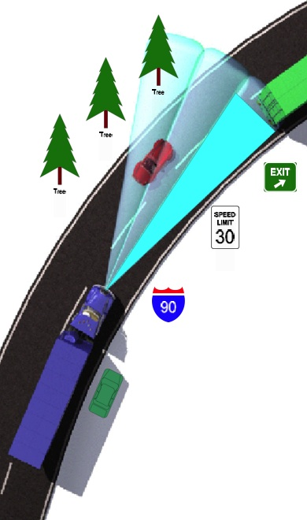

Figure 25 Illustration of sensitivity zone. (Courtesy Bendix)

11.5 International Perspective
Systems are available from European brake suppliers. ACC is available on European motive trucks as an extension to EBS. It is also available in the USA in conjunction with ESC.

11.6 Australian Requirements
ACC is available on some European motive trucks sold in Australia.

11.7 Technical Standards
An International Standards Organization working group is developing a standard for passenger car ACC and AEB (see next section).

It is proposed to limit the maximum braking rate of ACC to 0.3g.

11.8 Features and Limitations
False actuation has the potential to create hazards.

The detector systems may fail to detect smaller objects (motorcyclists). Further, the detector may be affected by poor weather.

Concern is sometimes expressed that rain and fog may affect radar returns. It is unlikely that modern radar systems are vulnerable.

Un some applications, the system can operate even though the driver has not set cruise control operation. Such a system incorporates some aspects of autonomous emergency braking (see a following section).

12 Brake Assist

12.1 Common Names

Brake Assist
‘BAP’ - Brake Assist Program.
‘BAS’ – Brake Assist System
Brake Assist is one element of a Driver Assistance System (DAS)

12.2 Function
Manages the braking event when a sudden and severe brake pedal application is made.

Once triggered by the pedal Brake Assist applies all the service brakes and produces a minimum distance stop without loosing directional control. The ABS functionality is relied upon to avoid loss of directional control.

12.3 Components
Brake Assist is usually a standard feature of truck Electronically Controlled Braking System (EBS). It uses the EBS hardware and no additional hardware is required.

12.4 Configurations
There is no particular configuration.
Brake Assist is usually based on an EBS platform.

12.5 International Perspective
Brake Assist is an established technology for EBS. It evaluates the rate and level of the brake application, and if deemed to be an ‘emergency’ response by the driver, the brakes will be applied in a controlled way to at least 90% of the maximum available level.

12.6 Australian Requirements
None.

12.7 Technical Standards
There are no national or international technical standards.

12.8 Features and Limitations
Brake Assist assumes that maximum braking is desirable in the situation and it applies near full braking.

Australian road experience exists as per EBS experience. There has been little feedback on which to judge limitations that may exist.

12.9 Australian Applications
Brake Assist has been demonstrated on display vehicles but is not commercially available in Australia.

13 Autonomous Emergency Braking

13.1 Common Names

‘AEB’ - Autonomous Emergency Braking
‘PEB’ - Predictive Emergency Braking

‘BAS’ – Brake Assistance System

‘CMBS’ – Collision Mitigation Braking System

‘CMB’ – Collision Mitigation by Braking
Autonomous Emergency Braking is one element of a Driver Assistance System (DAS)

13.2 Function
Applies the brakes automatically when a pending frontal collision is sensed.

Uses radar sensing of the region in front of the truck together with knowledge of steering wheel direction, speed and lateral acceleration to predict a pending frontal collision.

There are three aspects to the response:
- Provides acoustic and optical warnings to the driver.
- Charges the service brake system for fast response.
- Applies all the service brakes at a high level.

Systems differ as to actions taken when a pending collision is sensed. Collision Mitigation Braking Systems (CMBS) apply the brakes when there is a high degree of certainty that a collision will occur. The purpose is to reduce the impact speed.

In the first stage audible and visual warnings are given. The brake system is charged by a minor brake application (~5%). This charges the air brake system. Brake time-savings of about 0.1s are expected.

In the second stage a minor brake application is made and the driver seatbelt is pre-tensioned. Audible and optical warnings are repeated. This happens typically 3s before collision.

Autonomous Emergency Braking is triggered when the deceleration needed to avoid a collision is estimated to be about 0.5g (5m/s²). Manufacturers might vary this level.

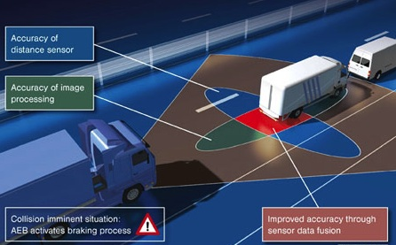

Figure 26 Illustration of AEB sensitivity regions.

13.3 Components
Radar or ladar (laser radar) detectors. These detect objects and estimate the closing speed of the object.

A second independent detector is also used. This is usually a visual recognition system.

The detector system has a separate Electronic Control Module (ECM) communicates the crash predictions to an enhanced ESC controller.

A proportional relay valve is installed in each brake circuit in parallel with the service brake relay valve. An electrical signal triggers brake air application All brakes in each circuit are applied.

13.4 Configurations
There are no particular configurations.
ABS configurations apply.
AEB is added to an EBS platform.

13.5 International Perspective
AEB has been developed by European suppliers and is now offered as an optional feature on some European manufactured motive trucks.

AEB is to be mandated on new European heavy vehicles starting in 2013.

13.6 Australian Requirements
None.

13.7 Technical Standards
An International Standards Organization (ISO) working group is developing a standard for passenger car ACC and AEB.

13.8 Features and Limitations
False actuation has the potential to create hazards.

The detector systems may fail to detect smaller objects (pedestrians, cyclists, single trees and motorcyclists). Further, the detector may be affected by poor weather.

Concern is sometimes expressed that rain and fog may affect radar returns. It is unlikely that modern radar systems are vulnerable.

Road experience of AEB systems is being gained.

Existing systems assume that the trailer connected to the motive truck complies with the ECE R13 compatibility limits. This is likely not to be true for Australian vehicles. It could be that the computed necessary braking rate on Australian trucks differs from that on European trucks.

13.9 Australian Applications
AEB has only been installed on demonstration vehicles.

14 Lane Departure Warning

14.1 Common Names

‘LDW’ - Lane Departure Warning,

Lane Deviation Warning

Lane Assist

14.2 Function
Provides the driver with a warning when an unintended deviation out of a lane boundary occurs. The system using image recognition technology to analyze the vehicle position relative to lane markings. By monitoring the steering wheel position and direction indicator operation, the system assesses whether the lane deviation was deliberate or not.

Lane Deviation Warning does not apply the brakes. Rather it gives both audible and visual warnings to the driver.

14.3 Components
Lane Warning Departure may be an additional feature on motive trucks with an Electronic Stability System (ESS). It uses the sensors (including the steering wheel position sensor) that are inherent with ESS.

Additionally, LWD uses cameras on each side of the vehicle to identify lane markings.

A dedicated electronic control unit analyses the sensor and camera information. Warnings are given when a longitudinal road line is crossed unintentionally (i.e. without steering wheel change).

14.4 International Perspective
Lane Detection Warning (LDW) is available commercially on some European motive trucks.
It is under development for American trucks.
It is not mandated in any country.

14.5 Australian Requirements
None.

14.6 Technical Standards
None.

14.7 Features and Limitations
There is insufficient Australian experience on which to judge the limitations or effectiveness of performance.

The system requires lane markings (including shoulder lines) to exist, otherwise it is ineffective.

LDW is potentially useful on major highways and roads that have lane marking in good condition. It is not applicable to gravel roads.

14.8 Australian Applications
LDW is available as an additional feature on some European motive trucks that are marketed in Australia.

15 The Controlled Area Network (CAN) Communication Bus

A ‘bus’ in this context is a electrical wire connection between embedded micro-controllers that provides the communication of data between these separated electronic devices.

The Can Bus (Controller Area Network) is European in origin (Robert Bosch GmBH) but now has world-wide application. It consists of two active wires (in a balanced differential configuration) with a third optional shield (sheath) wire. Error checking protocols and twisted pair wiring have proven to be effective at eliminating external interference, so the shield wire may be dropped.

The CAN Bus implements serial communication. The bus is widely used in industrial and automotive (car and truck) applications that have distributed microprocessors with no dominant (or controlling) element.

Each node uses male 9-pin D connector (industrial) or a three-pin (Deutsch) connector (automotive) with termination resistors (120 ohm) to minimize bounces. Coding is used (‘NRZ: Non Return to Zero’) to achieve compact messages with a minimum number of transitions and a high resilience to external disturbance.

The SAE J1939 serial data bus protocol is in widespread use on North American manufactured vehicles and equipment. Since year 2000 the USA (SAE J1939) and European (ISO 1187 CAN) standards have been harmonized. Voltage levels can be 5V, 12V or 24V as selected by the vehicle manufacturer. The voltage levels must be the same for interconnected CAN networks to work.

Unconnected CAN nodes must be terminated with a 120 ohm resistor. Otherwise electrical reflections occur that can disrupt the bus operation.
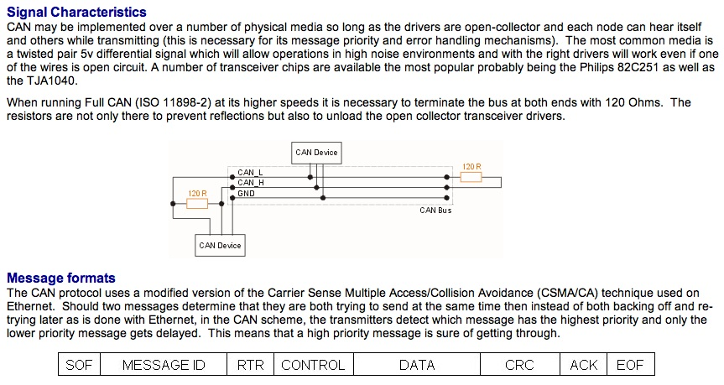
A good review of CAN bus technology is at:
www.computer-solutions.co.uk/info/Embedded_tutorials/can-tutorial.html

There are several different physical forms of the CAN bus that comply to various standards:

ISO 11898-1: CAN data link and physical signalling
ISO 11898-2: CAN high-speed medium access unit.
ISO 11898-3: CAN low-speed, fault tolerant, medium-dependent interface.
ISO 11898-4: CAN: Time triggered communication
ISO 11898-5: CAN High-speed access with low power mode.
ISO 11992-1: CAN fault-tolerant for truck/trailer communication.
ISO 11783-2: 250 k/bit/s, agricultural standard.
SAE J1939-11: 250 kbit/s, shielded twisted pair.
SAE J1939-15: 250 kbit/s, unshielded twisted pair (UTP) reduced layer.
SAE J2411: Single wire CAN (SWC).

The physical implementation on European heavy vehicles is a moderate speed CAN according to ISO 11898 Part 2 or ISO 11992-1 with speed to 250 kbit/s, limited to30 devices and with a maximum bus length of 40m. The North American implementation is according to SAE J1939.

SEA J1939-81 defines unique names and address formats for automotive functions. In the braking domain provision has been made for the sensors likely to be used for braking and stability control.

The North American implementation of a J1939 CAN bus has 5V signal levels. The European and Japanese implementation version of automotive CAN has 24V signal levels. The ISO CAN standards do allow for 12V CAN levels, as used on passenger cars.

Typically a CAN running to the trailer will communicate at 125 kB/s. Currently electronically controlled brake systems provide the main motivation for CAN communication between trucks and trailers.

Additional protocols (such as: SAE J1587 and J2797) are applied to allow personal-computer access to the CAN network for diagnostic purposes.

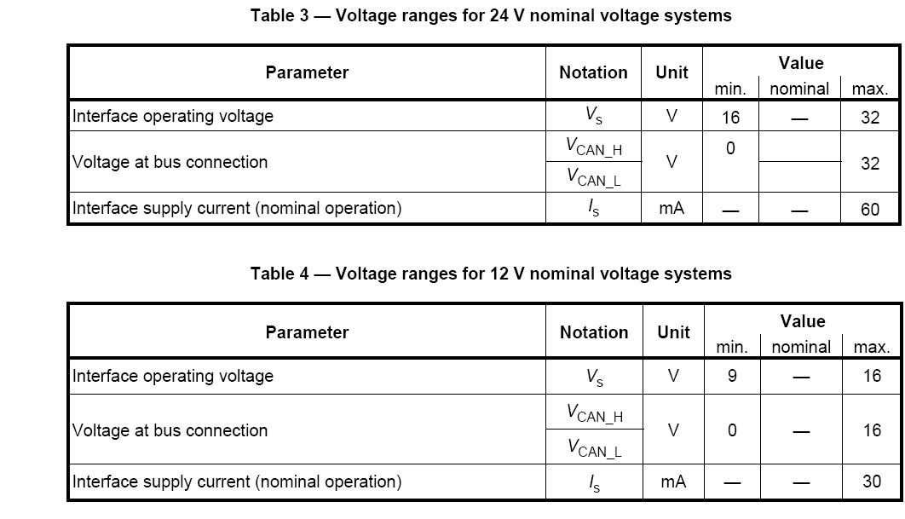
Figure 11 Voltage and current ranges for CAN bus.

The following information illustrated the J1939 CAN Message Formats – Brake Communication with Engine Controller as implemented in the MTU Detroit Diesel, DEDEC IV engine controller.

Message Format
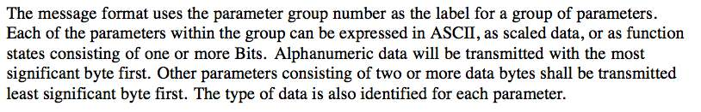
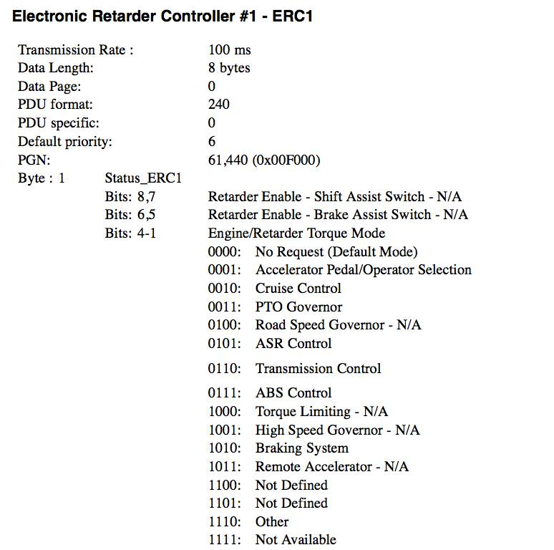

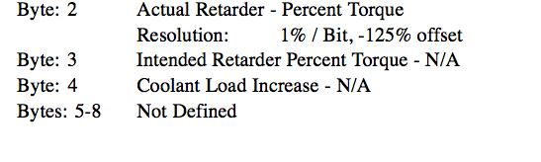
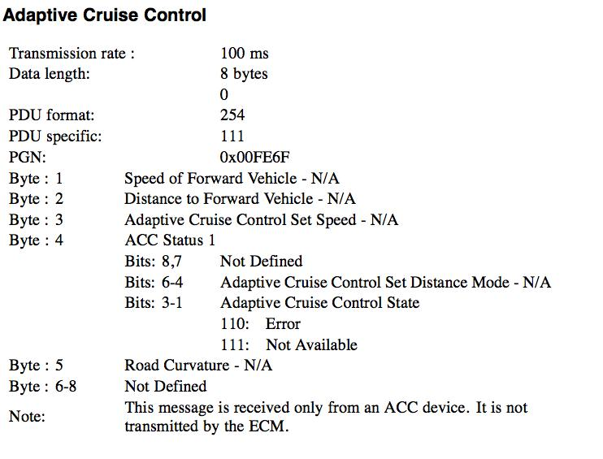
(Courtesy MTU Detroit Diesel)
The engine controller can be programmed to respond to requests from the brake control ECM or the cruise control ECM because CAN communication is possible.

Further reading:

ISO / DIS 11898-1 Road vehicles – Controller area network (CAN) –
Part 1 :Data link layer and physical signalling.
Part 2: High speed medium access unit.
Part 3: Low speed fault tolerant medium dependent interface.
Part 4: Time triggered communication

ISO 11992-1: CAN fault-tolerant for truck/trailer communication.

www.semiconductors.bosch.de/pdf/can2spec.pdf

SAE J1939 Recommended Practice for a serial control and communication vehicle networks.

www.computer-solutions.co.uk/info/Embedded_tutorials/can-tutorial.html

Glossary

Antilock Brake System - Acts to prevent wheel lock up during braking by altering the service brake control level at ABS a controlled wheel to release the wheel. As not all wheels on a vehicle are usually sensed
but all wheels are usually controlled, some wheels might be released that are not on the point of locking up.

ABS Platform - A basic ABS system to which is added additional functional elements such as ESC, ACC or Brake Assist.

Adaptive Cruise Control - A system that applies the auxiliary brake and if necessary the service brake to increase
ACC the separation distance (i.e. the distance between the truck and the vehicle immediately in front) when the cruise control is operating.

Anti Skid Brakes – see ABS

Australian Design Rules – The national standards for new vehicles. The current applicable braking rules are ADRs ADR 35/03 (trucks) and ADR 38/04 (trailers)

Automatic Brake Adjuster - A mechanical device that adjusts individual service brakes at each brake application to keep the individual brake in good adjustment. An ABA must be set-up correctly each time the brake linings / pads are changed.

Autonomous Emergency Braking – A system that automatically applies the service brakes so as to avoid or
AEB minimize the impact of a collision. The system uses advanced visual and / or radar techniques to identify a likely collision situation.

Automatic Traction Control - A system that acts to prevent drive wheel slipping during tractive effort. It is always
ATC available in conjunction with ABS.

Auxiliary Brakes - A mechanical or electrical devise that produces retarding action at the drive wheels of a truck that does not involve service brake action. Typically the auxiliary brake action is provided by an:
engine brake,
exhaust brake,
tail-shaft retarder
transmission retarder
regenerative braking transmission.
Future developments might see introduction of auxiliary brakes for trailers.

Available tyre-road friction - The ratio of retardation force / weight force for a tyre on a road surface at which the tyre is on the point of locking up.

Brake Assist - A system that manages a severe service brake application so as to achieve optimum stopping
BA distance performance without loss of directional control.

Braking coefficient (longitudinal) – The ratio of the longitudinal retardation force on an axle / weight carried by the axle. The term can also be applied to the total retardation and weight force ratio of a vehicle part. Braking coefficient (longitudinal) is also called the friction utilization.

Braking coefficient (lateral) – The ratio of the lateral (cornering) forces on an axle / weight carried by the axle. The term can also be applied to the total lateral force and weight force ratio of a vehicle part. Braking coefficient (lateral) is also called the cornering coefficient.

CAN bus - An electronic communication bus (wiring system involving three wires) for
Controlled Area Network communication of information between distributed micro-controllers and sensors on trucks and trailers.

Coupling Force Control - a system that manages the control signal level to the trailer in order to improve the brake
CFC compatibility balance.

Drag Torque Control – A system that increases the engine fuelling level to reduce drag on the rear (drive) axles.
DTC The auxiliary retarder may also be disabled.

Electronic Brake Distribution - An electronic control system that is integrated with either ABS or EBS that
EBD alters the service brake level between axles on a vehicle in response to the estimated load level. This function is comparable to LSB although the methods of control are different.

Electronic Brake Safety System – A electronic brake control system marketed by Kenworth Australia that
EBSS incorporates ABS, EBD and electronic trailer signalling. It can have ECS as an option.
EBSS should not be confused with EBS.

Electronic Control Module – An electronic unit that implements programmed brake functions in response to signals
ECM and switch positions. The action is implemented electronically via output circuits. ECM for trucks can either be 12V powered (based on North American practice) or 24V powered based on European and Japanese practice.

Electronically (Controlled) Brake System - A high-level brake control system that communicates brake control
EBS information between sensors and actuators using electronic CAN communication. EBS includes Coupling Force Control and electronic signalling to trailers. EBS is available on all European trucks and some Japanese trucks. It is not available on North American or Australian manufactured trucks.

Electronic Stability Control – Acts to improve truck trajectory by applying selected brakes, controlling engine
ESC , ESP torque and providing wheel lock-up protection. The system monitors the wheel speeds, steering wheel location and lateral acceleration to identify poor or unsafe conditions and to implement a corrective response.

EBS Platform – A basic EBS system to which is added additional functional elements such as ESC, ACC and Brake
Assist.

Load Sensing Brakes - A pneumatic control system that reduces the brake control level to one (or more) axle
LSB groups on a vehicle by a ratio determined by the load on a sensed axle. The ratio is pre-set and adjustable. On a truck the drive-group brake level is reduced when the load is light.

Lane Departure Warning - A system that warns the driver when the truck moves across a lane marking (or off a
LDW sealed pavement) without any driver steering input.

Modulator Valve – A pneumatic valve with electronic control that acts to either allow, block or release service air brake pressure to the service brake actuators.

Actuating Modulator – A modulation that has the added capability of applying air pressure from a reservoir into the service

Retractable (Lift) Axles - A design that causes one or two axles to be lifted when a vehicle is lightly laden. The lifting force is usually pneumatic and the lift control electronic. This system alters the brake distribution on a truck or a trailer.

Roll Stability System - A system that predicted impending vehicle roll-over and acts to reduce the vehicle speed
RSS by applying service brakes.

Sense Low Strategy - Installation of wheel sensors onto the wheels that lock-up first on an axle. Other unsensed wheels in the axle group are controlled according to the sensed wheel speeds.

Sense High Strategy - Installation of wheel sensors onto the wheels that lock-up last on an axle group. Other unsensed wheels in the axle group are controlled according to the sensed wheel speeds.

Trailer Electronically (Controlled) Brake System - A high-level brake control system that communicates brake
Trailer EBS control information between sensors and actuators using electronic CAN communication.

Trailer Response Management - the general name for the management of the brake control level on a trailer.
TRM There are two aspects. Firstly Coupling Force Control and secondly Trailer Response Signalling.

Vehicle Satiability Program - see ESC

Wheel slip 1- actual wheel speed / free running wheel speed. A tyre typically locks up at a slip of about 0.15.

Wheel Speed Sensor – In the usual form this a wheel speed sensor is a coil of wire wound onto a magnet core. It is placed close to a moving pole ring on an axle. A varying voltage is induced in the coil that provides wheel speed information to an ECM.

17 Acknowledgements

Principal author: Peter Hart.

The assistance of the following people who contributed to, and reviewed drafts of this document is gratefully acknowledged:
Mr Greg Byrnes, Airbarke Corporation,
Mr Tony Cheyne, Wabco,
Mr Mario Colosimo and Mr Ian Thompson, BPW Transpec,
Mr Adam Woltanski and Mr Rob Smedly, Knorr Bremse.

Knorr Bremse, Wabco, Bendix Corporation and Airbrake Corporation have provided some of the figures in this document. This is gratefully acknowledged.

